# VIVEKANAND EDUCATION SOCIETY’S INSTITUTE OF TECHNOLOGY

**An Autonomous Institute Affiliated to University of Mumbai**

**Department of Computer Engineering**



Project Report on

EnviroScan: Community and NGO Waste Solution

In partial fulfillment of the Fourth Year, Bachelor of Engineering (B.E.) Degree in Computer Engineering at the University of Mumbai Academic Year 2024-25

**Submitted by**

Shamal Dhekale - D17A - 13

Chandni Gangwani - D17A - 16

Bhagyashree Vaswani - D17A - 66

**Project Mentor**

Mrs. Rupali Soni

(2024-25)

# VIVEKANAND EDUCATION SOCIETY’S INSTITUTE OF TECHNOLOGY

**An Autonomous Institute Affiliated to University of Mumbai**

**Department of Computer Engineering**



# Certificate

This is to certify that  ***Shamal Dhekale, Chandni Gangwani, Bhagyashree Vaswani*** of Fourth Year Computer Engineering studying under the University of Mumbai have satisfactorily completed the project on “***EnviroScan: Community and NGO Waste Solution***” as a part of their coursework of PROJECT-II for Semester-VIII under the guidance of their mentor ***Mrs. Rupali Soni*** in the year 2024-25 .

This thesis/dissertation/project report entitled ***EnviroScan: Community and NGO Waste Solution*** by ***Shamal Dhekale, Chandni Gangwani, Bhagyashree Vaswani*** is approved for the degree of ***B.E. Computer Engineering***.

| Programme Outcomes | Grade |
| --- | --- |
| PO1,PO2,PO3,PO4,PO5,PO6,PO7,  PO8, PO9, PO10, PO11, PO12  PSO1, PSO2 |  |

Date:

Project Guide:

# Project Report Approval

**For**

**B. E (Computer Engineering)**

This thesis/dissertation/project report entitled ***EnviroScan: Community and NGO Waste Solution*** by ***Shamal Dhekale, Chandni Gangwani, Bhagyashree Vaswani*** is approved for the degree of **B.E. Computer Engineering.**.

Internal Examiner

---------------------------------------------

External Examiner

---------------------------------------------

Head of the Department

-----------------------------------------------

Principal

-----------------------------------------------

Date:

Place:

# 

# Declaration

We declare that this written submission represents our ideas in our own words and where others' ideas or words have been included, we have adequately cited and referenced the original sources. We also declare that we have adhered to all principles of academic honesty and integrity and have not misrepresented or fabricated or falsified any idea/data/fact/source in our submission. We understand that any violation of the above will be cause for disciplinary action by the Institute and can also evoke penal action from the sources which have thus not been properly cited or from whom proper permission has not been taken when needed.

| -----------------------------------------  (Signature)  -----------------------------------------  ( Shamal Dhekale - 13 ) | -----------------------------------------  (Signature)  -----------------------------------------  (Chandni Gangwani - D17A - 16 ) |
| --- | --- |
| -----------------------------------------  (Signature)  -----------------------------------------  (Bhagyashree Vaswani - 66 ) |  |

Date:

# ACKNOWLEDGEMENT

We are thankful to our college Vivekanand Education Society’s Institute of Technology for considering our project and extending help at all stages needed during our work of collecting information regarding the project.

It gives us immense pleasure to express our deep and sincere gratitude to Assistant Professor(**Project Guide**) for her kind help and valuable advice during the development of project synopsis and for her guidance and suggestions.

We are deeply indebted to Head of the Computer Department **Dr.(Mrs.) Nupur Giri** and our Principal **Dr. (Mrs.) J.M. Nair ,** for giving us this valuable opportunity to do this project.

We express our hearty thanks to them for their assistance without which it would have been difficult in finishing this project synopsis and project review successfully.

We convey our deep sense of gratitude to all teaching and non-teaching staff for their constant encouragement, support and selfless help throughout the project work. It is a great pleasure to acknowledge the help and suggestion, which we received from the Department of Computer Engineering.

We wish to express our profound thanks to all those who helped us in gathering information about the project. Our families too have provided moral support and encouragement several times.

**Computer Engineering Department**

# COURSE OUTCOMES FOR B.E PROJECT

Learners will be to,

| **Course Outcome** | **Description of the Course Outcome** |
| --- | --- |
| CO 1 | Able to apply the relevant engineering concepts, knowledge and skills towards the project. |
| CO2 | Able to identify, formulate and interpret the various relevant research papers and to determine the problem. |
| CO 3 | Able to apply the engineering concepts towards designing solutions for the problem. |
| CO 4 | Able to interpret the data and datasets to be utilized. |
| CO 5 | Able to create, select and apply appropriate technologies, techniques, resources and tools for the project. |
| CO 6 | Able to apply ethical, professional policies and principles towards societal, environmental, safety and cultural benefit. |
| CO 7 | Able to function effectively as an individual, and as a member of a team, allocating roles with clear lines of responsibility and accountability. |
| CO 8 | Able to write effective reports, design documents and make effective presentations. |
| CO 9 | Able to apply engineering and management principles to the project as a team member. |
| CO 10 | Able to apply the project domain knowledge to sharpen one’s competency. |
| CO 11 | Able to develop a professional, presentational, balanced and structured approach towards project development. |
| CO 12 | Able to adopt skills, languages, environment and platforms for creating innovative solutions for the project. |

# Index

| **Chapter No** | **Title** | **Page No.** |
| --- | --- | --- |
| **1** | **Introduction** |  |
| 1.1 | Introduction to the project | 12 |
| 1.2 | Motivation for the project | 13 |
| 1.3 | Problem Definition | 13 |
| 1.4 | Existing Systems | 14 |
| 1.5 | Lacuna of the Existing Systems | 15 |
| 1.6 | Relevance of the Project | 16 |
| **2** | **Literature Survey** |  |
| A | Brief overview of Literature Survey | 17 |
| 2.1 | Research Papers  Abstract of the research paper  Inference drawn from the paper | 17 |
| 2.2 | Patent Search | 25 |
| 2.3 | Inference Drawn | 26 |
| 2.4 | Comparison with the Existing Systems | 27 |
| **3.** | **Requirement Gathering for the proposed System** |  |
| 3.1 | Introduction to Requirement Gathering | 28 |
| 3.2 | Functional Requirements | 29 |
| 3.3 | Non-Functional Requirements | 29 |
| 3.4 | Hardware, Software, Technology and tools utilised | 30 |
| 3.5 | Constraints | 30 |
| **4.** | **Proposed Design** |  |
| 4.1 | Block diagram of the system | 32 |
| 4.2 | Modular design of the system | 34 |

| 4.3 | System Design | 34 |
| --- | --- | --- |
| 4.4 | Project Scheduling &amp; Tracking using Timeline / Gantt Chart | 37 |
| **5.** | **Implementation of the Proposed System** |  |
| 5.1 | Methodology employed for development | 38 |
| 5.2 | Algorithms and flowcharts for the respective modules developed | 39 |
| 5.3 | Datasets source and utilization | 40 |
| **6.** | **Testing of the Proposed System** |  |
| 6.1 | Introduction to testing | 41 |
| 6.2 | Types of tests Considered | 41 |
| 6.3 | Various test case scenarios considered | 42 |
| **7.** | **Results and Discussions** |  |
| 7.1 | Screenshots of User Interface (UI) for the respective module | 44 |
| 7.2 | Performance Evaluation measures | 47 |
| 7.3 | Input Parameters / Features considered | 49 |
| 7.4 | Comparison of results with existing systems | 50 |
| 7.5 | Inference drawn | 50 |
| **8.** | **Conclusion** |  |
| 8.1 | Limitations | 52 |
| 8.2 | Conclusion | 52 |
| 8.3 | Future Scope | 53 |
|  | **References** |  |
|  | **Appendix** |  |
| **1** | **Paper I** |  |
| a | Paper I |  |
| b | Plagiarism Report of Paper I |  |
| c | Project review sheet  i. Review 1 (1st March, 2025)  ii. Review 2 (1st April, 2025) |  |

# LIST OF FIGURES

| **Figure No** | **Heading** | **Page No** |
| --- | --- | --- |
| 4.1 | Block diagram of the System | 32 |
| 4.2 | Modular Diagram of the System | 34 |
| 4.3.1 | DFD Level 0 | 34 |
| 4.3.2 | DFD Level 1 | 35 |
| 4.3.2 | DFD Level 2 | 36 |
| 4.4 | Gantt chart | 37 |
| 5.2.1 | Flow Chart | 39 |
| 7.1.1 | Sign In Page | 44 |
| 7.1.2 | User Login | 44 |
| 7.1.3 | Complaints page | 44 |
| 7.1.4 | NGO Register | 44 |
| 7.1.5 | NGO Login | 45 |
| 7.1.6 | Events Page | 45 |
| 7.1.7 | YOLOv12 Model Predictions on Test Image 1 | 46 |
| 7.1.8 | YOLOv12 Model Predictions on Test Image 2 | 46 |
| 7.2.1 | Model Performance | 47 |
| 7.2.2 | Box Loss | 47 |
| 7.2.3 | Class Loss | 48 |
| 7.2.4 | Object Loss | 48 |

# LIST OF TABLES

| **Table No** | **Heading** | **Page No** |
| --- | --- | --- |
| 1 | Comparing with Existing Systems | 27 |
| 2 | Requirements of the system | 28 |
| 3 | Comparison of Results with Existing System | 50 |

# Abstract

Waste, particularly plastic waste, poses a major challenge to environmental sustainability, overwhelming current management systems. The integration of advanced object detection technology offers a solution by accurately detecting and quantifying plastic waste from community-reported videos or photos of dumpsters. This data-driven approach enables NGOs to optimize resource allocation for waste collection and segregation, significantly improving efficiency and reducing operational bottlenecks. Additionally, the system promotes environmental engagement through features such as event announcements, educational content, and sustainability news, encouraging active community participation. Key findings highlight improvements in NGO operations, reduced waste collection times, and increased community involvement in sustainability efforts. The implications of this technology extend to scalable solutions for both urban and rural waste management, offering an innovative approach to addressing plastic waste challenges. By merging machine learning with community action, this solution bridges the gap between technology and environmental stewardship, empowering both NGOs and communities to work collaboratively towards effective waste management.

# 

# Chapter 1 : Introduction

This chapter presents an overview of the project, exploring the motivation, challenges in existing waste management systems, and the innovative solutions proposed through our platform. It highlights how cutting-edge object detection technology empowers users and NGOs to report and manage waste more efficiently by analyzing media submissions to detect and quantify plastic waste. The platform optimizes resource allocation, streamlines waste collection, and enhances community engagement through real-time updates and educational content on sustainable practices. By addressing critical gaps in recycling infrastructure and public awareness, this project aims to foster cleaner, more sustainable environments.

## 1.1. Introduction to the project

In the era of rapid technological advancements and increasing environmental concerns, our project emerges as a beacon of innovation and community empowerment in waste management. Our platform leverages cutting-edge object detection technology to enable users to report issues related to dumpsters in their vicinity by simply uploading videos or photos. This technology meticulously analyzes the media to detect and count the number of plastic items, providing an accurate assessment of waste quantities.

This feature is transformative for NGOs engaged in waste management drives. Armed with precise data, these organizations can better allocate their resources—trucks, collectors, manpower, and plastic bags—streamlining their operations and significantly reducing the time and effort required for waste segregation. This allows NGOs to focus more on the impactful work of cleaning and less on logistical challenges.

Our platform is designed to foster a collaborative community spirit. NGOs can post about upcoming drives and events, inviting the community to participate and contribute to the cause. This not only helps in mobilizing resources but also strengthens the bond between the organization and the community it serves.

Furthermore, our project is dedicated to spreading awareness and education about environmental sustainability. The platform offers a wealth of news and articles on innovative ways to reduce, reuse, and recycle, keeping users informed and engaged. By promoting best practices and new technologies in waste management, we aim to inspire individuals and communities to take proactive steps towards a cleaner, greener future.

In essence, our project is more than just a technological solution; it is a comprehensive platform that empowers NGOs, engages communities, and promotes environmental stewardship. Together, we can make a significant impact in managing waste more efficiently and creating a sustainable environment for future generations.

## 1.2. Motivation for the project

The motivation behind the EnviroScan project lies in our dedication to empowering communities and fostering environmental stewardship through innovation. Waste management, particularly the rampant issue of plastic pollution, poses significant challenges for both local communities and NGOs. With limited resources and inefficient processes, the task of tracking, segregating, and managing waste can often feel overwhelming. Through EnviroScan, we aim to leverage advanced object detection technology to simplify waste reporting and resource allocation, enabling more effective waste management. By providing a platform that not only enhances operational efficiency but also engages the community, we hope to drive collective action towards a cleaner and more sustainable future. EnviroScan embodies our belief that technology, when used responsibly, can be a powerful tool to solve real-world problems and foster collaboration. We envision a future where technology serves as a catalyst for environmental awareness, helping individuals and organizations unite in the shared goal of protecting our planet for future generations.

## 1.3. Problem Definition

In an era of rapid urbanization and growing environmental concerns, efficient waste management remains a significant challenge for both urban and rural communities. Despite efforts by governments, NGOs, and community organizations, many regions continue to struggle with ineffective waste handling. Issues such as improper disposal of recyclable materials, lack of public awareness, and insufficient infrastructure contribute to worsening environmental conditions, particularly the overwhelming accumulation of plastic waste. These shortcomings not only threaten public health and hygiene but also exacerbate the global waste crisis.

This project addresses these challenges by leveraging cutting-edge technology with a strong focus on community engagement and education. At its core, the initiative employs advanced waste detection and monitoring systems that utilize object detection technology to accurately identify, quantify, and categorize waste from user-submitted photos and videos. This provides valuable data on waste composition and distribution, enabling more informed decision-making in waste management strategies.

Beyond technological advancements, the project emphasizes the importance of public participation and environmental education. Awareness campaigns are designed to inform individuals about the benefits of recycling and responsible waste disposal, fostering a culture of sustainability. Additionally, the platform includes a robust complaint management system that allows residents to report waste-related issues in real-time. This ensures efficient responses to waste management concerns while promoting transparency and accountability.

Ultimately, this initiative extends beyond waste detection—it creates a collaborative ecosystem where communities are empowered to take responsibility for their environment. By integrating technology, public involvement, and education, the project promotes cleaner, greener, and more sustainable living spaces, paving the way for a future where waste management is a shared commitment among individuals and organizations.

## 1.4. Existing Systems

1. Smart Waste Management Systems
   1. Enevo: Uses IoT-enabled smart sensors to monitor waste levels in bins and optimize collection routes, reducing costs and environmental impact.
   2. Compology: Provides AI-powered camera-based waste monitoring to track bin fullness and contamination.
   3. Bigbelly: A solar-powered smart bin system with built-in compactors that reduce waste collection frequency.
2. AI-Based Waste Sorting and Detection
   1. WasteVision: Uses AI-driven object detection for waste sorting, reducing manual sorting efforts and improving recycling efficiency.
   2. TrashBot by CleanRobotics: An AI-powered smart bin that automatically sorts recyclables and landfill waste using sensors and machine learning.
3. Community-Driven Waste Reporting Platforms
   1. SeeClickFix: Allows citizens to report waste issues, illegal dumping, and other civic problems to local authorities.
   2. Litterati: A crowdsourced platform where users can upload images of litter, helping track and reduce waste pollution through community participation.
4. Blockchain-Based Waste Tracking
   1. Plastic Bank: Uses blockchain to incentivize plastic waste collection in developing countries by converting waste into digital currency.
   2. RecycleGO: Uses blockchain to improve waste tracking and ensure accountability in recycling supply chains.
5. Government and NGO Initiatives
   1. Swachh Bharat Mission (India): A large-scale national program aimed at improving sanitation and waste management through community participation.
   2. Zero Waste Cities (EU): Encourages cities to adopt circular economy principles to reduce waste generation and improve recycling rates.

## 1.5. Lacuna of the existing system

While the existing systems may have made significant strides in improving accessibility for domestic waste management, there are still areas where they may have limitations or room for improvement:

* Inadequate Recycling Facilities: Many regions lack sufficient recycling infrastructure, leading to recyclable materials being disposed of improperly. Even where facilities exist, they are often underfunded and inefficient, discouraging public participation in recycling.
* Inefficient Collection Schedules: Waste collection schedules frequently fail to match actual community needs, resulting in overflowing dumpsters, delays, and missed pickups, contributing to environmental and hygiene issues.
* Limited Public Awareness: A lack of widespread education on sustainable waste management practices leads to improper disposal and low recycling participation.
* Poor Data Integration: Current systems often lack real-time data and analytics integration, hindering efficient decision-making and operational effectiveness.
* Slow Response to Complaints: Existing complaint management systems are typically slow, leading to unresolved waste-related issues and dissatisfaction among residents.

## 1.6 Relevance of the Project

The relevance of this project is rooted in the pressing global need for sustainable and efficient waste management systems, especially in the face of growing urbanization and escalating environmental challenges. With increasing amounts of waste, particularly plastics, being improperly disposed of, the impact on ecosystems, public health, and urban hygiene is becoming more severe. This project directly addresses these concerns by introducing a technology-driven solution that optimizes waste collection and recycling processes, thereby reducing environmental pollution and promoting a cleaner living environment.

Moreover, the project is highly relevant to community-driven environmental initiatives. By integrating real-time waste monitoring and detection systems, it enhances operational efficiency for waste management organizations, particularly NGOs. The project’s focus on public awareness and education also ensures that individuals are equipped with the knowledge to actively participate in sustainable waste practices, making this initiative a critical tool in fostering environmental stewardship.

In the broader context, this project contributes to global sustainability goals, aligning with efforts to reduce plastic waste, minimize landfill usage, and promote recycling and responsible waste disposal. By empowering communities and organizations to collaborate through a shared platform, the project is poised to have a lasting impact on how waste is managed at both local and regional levels.

# Chapter 2: Literature Survey

**A.Overview of literature survey:**

The reviewed papers focus on various waste detection techniques, community-driven waste management approaches, and AI-based waste classification systems. These studies help in understanding how technology, public participation, and environmental awareness contribute to effective waste management solutions. The literature examines different methodologies for automated waste identification, real-time monitoring, and data-driven decision-making to improve waste handling processes. Overall, these studies emphasize the need for an integrated approach that combines technology and community engagement to develop a comprehensive system for waste detection, reporting, and environmental education.

## 2.1. Research Papers

**E-Safe: An E-waste Management and Awareness Application using YOLO Object Detection**

**Abstract :** Technology and related fields are advancing rapidly in today’s era, which is leading to the increased usage of electronic equipment especially mobile phones. This rapid growth in the usage of technological equipment gives rise to E-waste generation since the advancement in technology forces the users to replace their existing equipment with the advanced ones. This throw on the scrapheap is increasing exponentially, leading to the immense generation of E-waste. The growing amount of waste must be properly handled and disposed of. E-waste mainly consists of chemicals and metals, which can be harmful or toxic in nature. Giving a blind eye to the handling of this waste can lead to great mishaps. Here, it mainly focuses on the technologies used for the handling of E-waste and provides a technical solution, which is an Android Application. This will take the image for processing and based on YOLO algorithms, it will identify the electronic device from the image and will list out the components of the identified device. The final output of the application will make the E-waste management process easier for managing data and will work as an awareness tool to make people aware about the E-Waste threats.

**Inference drawn from the paper : Prof. Khalid Alfatmi, Ms. Falguni Shashikant Shinde et al. (2023)** The paper highlights the urgent issue of electronic waste (e-waste) generation due to the rapid advancement and increased usage of electronic devices, particularly mobile phones, which compels users to frequently upgrade to newer models. This surge in e-waste, containing harmful chemicals and metals, poses significant environmental and health risks if not properly managed. To address these challenges, the paper proposes an innovative Android application that employs YOLO (You Only Look Once) algorithms to process images of electronic devices, identify them, and list their components. This application aims to simplify e-waste management by organizing data while simultaneously serving as an awareness tool to educate the public about the dangers associated with e-waste. Ultimately, the paper advocates for leveraging technology to enhance e-waste handling practices and promote responsible disposal methods.

**2) Implementation of Faster Region-Based Convolutional Neural Network for Waste Type Classification**

**Abstract :** The improper disposal of garbage is one of the factors that contribute to the problems that are visible in the environment, and these problems have a significant influence. The digestive issue is one of the problems caused by the increase in the population of insects and the variety of different types of pests. If waste is not recycled and managed effectively, it can negatively impact economic growth and contribute to air pollution and other health issues. Integrating computer technology, such as object recognition, might be helpful in waste management. At this point, the most popular approach to object detection is called deep learning. Therefore, this paper presents a waste recognition using Faster Region-Based Convolutional Neural Network. The research focused on recognizing plastic and disposable diapers as two separate classes since disposable diapers and plastics are essential in modern society. Convolutional neural network (CNN) which comes under deep learning has been widely used in object recognition or classification due to its effectiveness. In the Faster RCNN, we used two separate networks to predict the region proposal reshaped by a Region of Interest (RoI) pooling layer to classify the images. From the result, it can be observed that our proposed system has achieved an average accuracy of 91.2%.

**Inference drawn from the paper : Jamilin Rashida, Raseeda Hamzah and et al. (2022)** The paper addresses the critical environmental issues stemming from improper waste disposal, which exacerbates insect populations and various pests, contributing to health and economic challenges. Ineffective waste management, particularly in recycling, can lead to air pollution and other significant health risks. To tackle these issues, the research introduces a waste recognition system utilizing a Faster Region-Based Convolutional Neural Network (Faster R-CNN), focusing specifically on identifying plastic waste and disposable diapers as two distinct categories. The study employs convolutional neural networks (CNNs), a prominent deep learning technique known for its efficacy in object recognition. The proposed system utilizes two separate networks to generate region proposals, which are then classified using a Region of Interest (RoI) pooling layer. The results demonstrate that the system achieved an impressive average accuracy of 91.2%, showcasing its potential as an effective tool in waste management and recycling efforts.

**3) SSD based waste separation in smart garbage using augmented clustering NMS**

**Abstract :** Object detection plays a pivotal role in autonomous systems that helps to build the machines to be intelligent as humans that leads to build an Artificial Intelligence application used for society,Industries,face-recognition and so-on. Nowadays, it is difficult to manage the waste generated by humans and industries which are increasing rapidly day by day. We need to address the problem to make automation for separating the Biodegradable and Nonbiodegradable waste. Although humans are trying to manage the impact of waste management in society to maintain the ecosystem by implementing a separate trash for Bio and Non-bio waste. Sometimes it is difficult to follow the separation of waste manually by humans. There is no existing sensor to identify the types of wastes. In this proposed system, it evolves the implementation of the biodegradable and nonbiodegradable object detection method to help to detect these objects automatically with the augmented clustering NMS using Single-shot detector methods. The enhanced augmented clustering algorithm effectively detects the multiple objects in the video along with the respective bio or non-bio classification custom object detection model. With the build thousand images for each class custom dataset model to train the objects using deep learning neural network. A custom object detection data model is built with the help of NVIDIA GPU RTX 4 GB using tensorflow model. Here the results are interpreted with the mean average precision value of 0.965 with ACNMS Single shot object detector which is effectively detected with the new enhanced technique.

**Inference drawn from the paper : M. Karthikeyan, T. S. Subashini and et al. (2021)** The paper highlights the crucial role of object detection in autonomous systems, enabling machines to achieve human-like intelligence and enhancing various applications, including those in society and industry, such as waste management. As the volume of waste generated by humans and industries continues to escalate, effective solutions for separating biodegradable and non-biodegradable waste are urgently needed. While efforts have been made to manage waste through designated trash bins, manual separation poses significant challenges. The proposed system addresses this gap by implementing an automatic detection method for biodegradable and non-biodegradable waste using an augmented clustering Non-Maximum Suppression (NMS) approach with Single Shot Detector (SSD) techniques. This enhanced augmented clustering algorithm efficiently detects multiple objects in video streams, categorizing them accurately as biodegradable or non-biodegradable. The system utilizes a custom dataset model, trained on thousands of images per class using deep learning neural networks and powered by an NVIDIA GPU RTX with 4 GB memory. The results demonstrate a mean average precision of 0.965 with the ACNMS SSD, showcasing the effectiveness of this innovative technique in waste classification.

**4) ScrapNet: An Efficient Approach to Trash Classification**

**Abstract :** As people have become more aware of their actions and how they affect their surroundings, they have realized the dire state of the environment. As a result, the recycling movement has gained momentum as a measure to save it. Contemporarily, the recycling industry has not seen a major shift and the problems that existed decades earlier persist. Trash classification is at the core of these problems, because if you can’t classify it, obviously you can’t recycle it. Manual classification often leads to misclassification as humans classify or judge things based on their experiences, knowledge, and not just absolute facts. Additionally, if the waste to be sorted is toxic, being in direct contact may be physically harmful to the people involved. Until a solution is found for this problem, the recycling industry won’t be on par with the rise in recycling culture. Thus, this is the problem we have set out to solve; this paper proposes a Deep Learning model based on EfficientNet Architecture that can classify different kinds of trash with an accuracy high enough to make it a viable solution for the industry while using a comparatively lower number of parameters than existing methods. We achieved an accuracy of 98% on the TrashNet dataset, the standard data for Trash classification, and outperformed all existing models. Additionally, as no large dataset with a varied set of trash images was present, we created a new dataset of 8135 images by combining various datasets and standardized them, achieving a classification accuracy of 92.87% with EfficientNet B3.

**Inference of the paper : Abhishek Masand , Suryansh Chauhan and et al. (2021)** The paper addresses the pressing issues of trash classification within the recycling industry, highlighting how the lack of effective classification techniques hampers recycling efforts despite the growing awareness of environmental issues. Manual classification methods often lead to misclassification due to subjective human judgment, which can be particularly dangerous when dealing with toxic waste. To tackle this problem, the study proposes a Deep Learning model utilizing EfficientNet Architecture, aimed at improving trash classification accuracy. The model achieves an impressive accuracy of 98% on the TrashNet dataset, surpassing existing models and demonstrating its potential as a practical solution for the recycling industry. Furthermore, recognizing the absence of a comprehensive dataset with diverse trash images, the authors developed a new dataset comprising 8,135 images from various sources, resulting in a classification accuracy of 92.87% with EfficientNet B3. This work not only advances trash classification technology but also supports the broader goal of enhancing recycling practices and promoting environmental sustainability.

**5) YOLO-Green: A Real-Time Classification and Object Detection Model Optimized for Waste Management**

**Abstract :** Deep neural networks (DNNs) play an important role in our daily lives, from aiding us in menial tasks to solving world issues such as cancer cell detection. However, few pieces of research have been conducted using DNNs and deep learning models as a medium to help classify and detect trash, in efforts to solve our global waste crisis. This is because current DNNs struggle to be both efficient and accurate while detecting indistinct objects such as waste. To address this issue, this work focuses on YOLO-Green, a novel real-time object detection model designed specifically for trash detection. The model is trained on a dataset gathered from real-world trash divided into seven of the most common types of solid waste. With only 100 epochs of training, YOLO-Green achieves an outstanding mAP of 78.04%, FPS of 2.72, while retaining a model size of only 117 MB. Based on the original object detection of YOLOv4, YOLO-Green exceeds YOLOv4 and other popular deep learning models in both its accuracy and efficiency, while maintaining a relatively small model size. Ultimately, this study sheds a positive light on the potential of using deep learning models as an alternative to manual waste management.

**Inference of the paper : Wesley Lin (2021)** This study highlights the potential of Deep Neural Networks (DNNs) in addressing global waste management issues, specifically through the development of YOLO-Green, a novel real-time object detection model tailored for trash classification. While DNNs have proven effective in various fields, their application in waste detection has been limited due to challenges in accurately identifying indistinct objects. YOLO-Green aims to overcome these challenges by training on a dataset comprising seven common types of solid waste, achieving an impressive mean Average Precision (mAP) of 78.04% with just 100 training epochs. The model operates at a frame rate of 2.72 FPS and maintains a compact size of only 117 MB, outperforming both YOLOv4 and other established deep learning models in terms of accuracy and efficiency. This research underscores the viability of employing advanced deep learning techniques as alternatives to traditional manual waste management practices, contributing positively to efforts in tackling the global waste crisis.

**6) Smart Waste Management: Waste Segregation using Machine Learning**

**Abstract :** In the digitized era, the role of smart mechanisms plays a vital role and one among them is the segregation of waste. To make use of proper disposal and waste management techniques, the segregation of wastes is essential. In the existing systems, drones are used for identifying waste using image processing, and deep learning and use GPS, and GSM methods to identify and send locations to the authorities. The enhancement achieved is to analyze and implement waste segregation with the help of image classification and multi-object detection. Waste management may therefore be done more efficiently with an accuracy of 95% with a mean average of 87.4% which in turn helps significantly to reduce labor costs.

**Inference of the paper : Gayathri Rajakumaran, Shola Usharani and et al. (2023)** This paper addresses the critical need for effective waste segregation in the context of modern waste management by exploring the integration of smart mechanisms. It highlights the use of drones equipped with image processing and deep learning technologies, coupled with GPS and GSM for location tracking, to identify waste. The research enhances existing systems by focusing on advanced image classification and multi-object detection techniques for waste segregation. The proposed approach achieves an impressive accuracy of 95% and a mean average precision of 87.4%, leading to more efficient waste management while significantly reducing labor costs. Ultimately, this study demonstrates the potential of technological integration in promoting sustainable waste disposal practices and addressing environmental challenges.

**7) Recyclable solid waste detection based on image fusion and convolutional neural network**

**Abstract :** The most solid waste image datasets usually contain only a single object with a plain background, which is quite different from the real environment. In addition, the waste images labeling process takes a long time and is labor cost. To address these problems, we proposed an effective method to extend the dataset based on image fusion. Herein, we use image fusion technology to make a recyclable solid waste dataset Trash-Fusion automatically, where the images contain different categories of objects with complex background, and all classification and location labels are collected in the process of image fusion. Moreover, an actual scene dataset Trash-Collect is constructed, images of which are downloaded from the Internet or collected by ourselves. A mixed dataset of Trash-Fusion and Trash-Collect is sent to several convolutional neural networks for training, and YOLO v5 achieves the highest detection precision with 60 FPS.

**Inference from the paper : Yao Xiao, Bin Chen and et al. (2024)** This paper proposes an innovative solution to the limitations of existing solid waste image datasets, which typically feature single objects against plain backgrounds, diverging from real-world scenarios. To tackle the challenges of labor-intensive image labeling and dataset diversity, we introduce a method utilizing image fusion technology to create an enhanced dataset called Trash-Fusion. This dataset comprises images featuring multiple categories of objects set against complex backgrounds, with all classification and location labels automatically generated during the fusion process. Additionally, we construct a real-world dataset named Trash-Collect, sourcing images from the internet and personal collections. By combining the Trash-Fusion and Trash-Collect datasets, we train several convolutional neural networks, with YOLO v5 achieving the highest detection precision at 60 FPS, thus demonstrating the effectiveness of our approach in improving waste detection in complex environments.

**8) Solid Waste Detection in Cities Using Remote Sensing Imagery Based on a Location-Guided Key Point Network With Multiple Enhancements**

**Abstract :** Solid waste is a widespread problem that is having a negative effect on the global environment. Owing to the ability of macroscopic observation, it is reasonable to believe that remote sensing could be an effective way to realize the detection and monitoring of solid waste. Solid waste is usually a mixture of various materials, with a randomly scattered distribution, which brings great difficulty to precise detection. In this article, we propose a deep learning network for solid waste detection in urban areas, aiming to realize the fast and automatic extraction of solid waste from the complicated and large-scale urban background. A novel dataset for solid waste detection was constructed by collecting 3192 images from Google Earth (with a resolution from 0.13 to 0.52 m), and then a location-guided key point network with multiple enhancements (LKN-ME) is proposed to perform the urban solid waste detection task. The LKN-ME method uses corner pooling and central convolution to capture the key points of an object. The location guidance is realized through constraining the key point locations situated on the annotated bounding box of an object. Multiple enhancements, including data mosaicing, an attention enhancement, and path aggregation, are integrated to improve the detection accuracy. The results show that the LKN-ME method can achieve a state-of-the-art AR 100 (the average recall computed over 100 detections per image) of 71.8% and an average precision of 44.0% for the DSWD dataset, outperforming the classic object detection methods in solving the solid waste detection problem.

**Inference from the paper : Huifang Li , Chao Hu and et al. (2023)** This paper presents a deep learning network designed for the detection and monitoring of solid waste in urban environments, addressing the widespread environmental issues caused by solid waste accumulation. Recognizing the challenges posed by the complex and varied nature of solid waste, we developed a novel dataset comprising 3,192 high-resolution images sourced from Google Earth, with resolutions ranging from 0.13 to 0.52 m. We introduce the location-guided key point network with multiple enhancements (LKN-ME) to facilitate the automatic extraction of solid waste from intricate urban backgrounds. The LKN-ME network employs corner pooling and central convolution techniques to identify key points of objects, with location guidance provided by constraining these points to the annotated bounding boxes. To further enhance detection accuracy, we integrate several improvements, including data mosaicing, attention enhancement, and path aggregation. The LKN-ME method achieves a state-of-the-art average recall of 71.8% and an average precision of 44.0% on the DSWD dataset, surpassing traditional object detection approaches and demonstrating its effectiveness in tackling the solid waste detection problem in urban settings.

**9) A Survey on Waste Detection and Classification Using Deep Learning**

**Abstract :** Waste or trash management is receiving increased attention for intelligent and sustainable development, particularly in developed and developing countries. The waste or trash management system comprises several related processes that carry out various complex functions. Recently, interest in deep learning (DL) has increased in providing alternative computational techniques for determining the solution to various waste or trash management problems. Researchers have concentrated on this domain, and as a result, significant research has been published, particularly in recent years. According to the literature, a few comprehensive surveys have been done on waste detection and classification. However, no study has investigated the application of DL to solve waste or trash management problems in various domains and highlight the available datasets for waste detection and classification in different domains. To this end, this survey contributes by reviewing various image classification and object detection models, and their applications in waste detection and classification problems, providing an analysis of waste detection and classification techniques with precise and organized representation and compiling over twenty benchmarked trash datasets. Also, we backed up the study with the challenges of existing methods and the future potential in this field. This will give researchers in this area a solid background and knowledge of the state-of-the-art deep learning models and insight into the research areas that can still be explored.

**Inference from the paper : Haruna Abdu, Mohd Halim Mohd Noor and et al. (2022)** This paper presents a comprehensive survey of waste management, focusing on the application of deep learning (DL) techniques to address various challenges in waste detection and classification across multiple domains. As both developed and developing countries increasingly prioritize intelligent and sustainable waste management systems, this study highlights the complexity of these processes and the growing interest in utilizing DL for effective solutions. Despite the existing literature on waste detection and classification, there has been a lack of studies specifically examining the application of DL in this field and compiling available datasets. To bridge this gap, our survey reviews various image classification and object detection models relevant to waste management, offering an organized analysis of techniques and compiling over twenty benchmarked trash datasets. Additionally, the paper discusses the challenges faced by current methods and explores future research potentials, providing researchers with a solid foundation in state-of-the-art DL models and identifying areas for further investigation in waste management.

**10) Real-Time Garbage Object Detection With Data Augmentation and Feature Fusion Using SUAV Low-Altitude Remote Sensing Images**

**Abstract :** Recently, a number of nature reserves have been shut down because of serious pollution from tourist garbage. Garbage monitoring in high-altitude natural reserves using small unmanned aerial vehicle (SUAV) remote sensing is an important and urgent need for environmental protection. In order to help cleaners to eliminate garbage more conveniently and quickly, a novel approach is proposed to detect scattered garbage regions in real time using low-altitude remote sensing videos captured by SUAVs. First, the high-resolution, low-altitude, multitemporal remote sensing images and videos containing scattered garbage were collected through SUAV and then proposed a data augmentation method to expand the training samples. Second, the Yolov4 detection network was used to classify the scattered garbage regions. Finally, the location of the object was roughly calculated according to the altitude, flight direction, global positioning system, and digital elevation model (DEM). Then, the garbage object was marked on the video, while the object location was marked on the map. Experimental results show that the proposed method achieves a mean accuracy of 91.34% and provides better performances on the real data set compared with state-of-the-art methods.

**Inference from the paper : Weiyang Chen , Haifeng Wang and et al. (2022)** This paper proposes a novel approach for monitoring garbage in high-altitude natural reserves using small unmanned aerial vehicles (SUAVs) equipped with low-altitude remote sensing capabilities. As pollution from tourist garbage poses a significant threat to the environment, timely detection and removal of waste are crucial. The study involves the collection of high-resolution, multitemporal remote sensing images and videos of scattered garbage through SUAVs, followed by a data augmentation method to enhance the training samples. The Yolov4 detection network is employed to classify the identified garbage regions, while the object location is estimated using altitude, flight direction, global positioning system (GPS) data, and digital elevation models (DEMs). The results indicate that this method achieves a mean accuracy of 91.34%, demonstrating superior performance on real datasets compared to existing state-of-the-art techniques, thereby facilitating more efficient garbage collection in sensitive ecological areas.

## 2.2. Patent Search :

**1. SMART WASTE MANAGEMENT SYSTEM (US10692178B2)**

**Inventor**: Aykut Karademir  
**Assignee**: Evreka Yazılım Anonim Şirketi  
This invention relates to a smart waste management system comprising wireless sensors, software, and communication modules to monitor fill levels of bins in real-time. The system helps optimize collection routes, minimize fuel consumption, and reduce overflow problems. It offers a dashboard for municipalities and waste collection firms to analyze waste generation data and improve operational decisions. Although focused on bin-level monitoring using IoT, it does not analyze images or involve community-submitted reports or environmental education.

**2. SYSTEM AND METHOD FOR IDENTIFYING RECYCLABLE ITEMS USING MACHINE LEARNING (US20200122274A1)**

**Inventor**: Daniel David Siroker  
**Assignee**: Google LLC  
This system utilizes deep learning techniques to classify items as recyclable or non-recyclable based on images. Users can capture and upload images of items, and the system determines their recyclability using a trained neural network. It is aimed at increasing environmental awareness and providing educational insights. While closely related in the object detection domain, it lacks community engagement tools or NGO resource optimization.

**3. SMART WASTE BIN USING IMAGE CLASSIFICATION FOR OBJECT DETECTION (WO2020047099A1)**

**Inventors**: Charles Yhap, Tanner Cook  
**Assignee**: CleanRobotics  
The invention includes a smart bin equipped with an image recognition module and sensors to sort waste into categories like recyclables and landfill items. A machine learning model runs on-device to perform real-time classification and mechanical sorting. Though effective in automating sorting at disposal points, it does not integrate with a platform for user-uploaded images or NGO operations.

## 2.3 Inference Drawn:

1. Integration of Advanced Object Detection
   1. YOLO, Faster R-CNN, and SSD significantly enhance waste classification efficiency.
   2. Our project can leverage deep learning for improved waste identification.
2. Real-Time Classification and Monitoring
   1. Real-time models like YOLO-Green demonstrate the importance of instant waste monitoring.
   2. A lightweight, efficient model can help NGOs and communities track waste in real-time.
3. Data Collection and Augmentation
   1. Studies emphasize the need for diverse datasets with complex backgrounds.
   2. Our system should incorporate varied waste types for better model generalization.
4. Awareness and User Engagement
   1. Mobile apps and educational features improve user participation in waste management.
   2. Our platform can integrate awareness modules to promote responsible disposal.
5. Automated Sorting and Classification
   1. Deep learning models achieve 90%+ accuracy in automated waste segregation.
   2. Implementing an automatic classification feature will enhance sorting efficiency.
6. Environmental Impact Considerations
   1. Research highlights the consequences of improper disposal on pollution and health.
   2. Our system should provide data-driven insights to assist environmental planning.

## 2.4. Comparison with the Existing Systems:

| **Other System** | **Our System** |
| --- | --- |
| Uses traditional waste classification methods. | Utilizes deep learning-based object detection (YOLO, Faster R-CNN, SSD) for accurate waste identification. |
| Limited or no real-time tracking. | Provides real-time waste classification and monitoring for NGOs and communities. |
| Often trained on limited datasets with simple backgrounds. | Uses diverse datasets, including real-world images with complex waste scenarios, to improve generalization. |
| Primarily focuses on waste collection. | Includes educational modules and mobile application features to promote responsible disposal. |

**Table No. 1: Comparing with Existing System**

# Chapter 3: Requirements for the proposed system

The requirements for the project titled **"EnviroScan: Community and NGO Waste Solution"** comprise the functional, non-functional needs, constraints, hardware and software specifics, tools and techniques applied so far, and a final project proposal after analyzing these requirements. These points are essential in shaping the direction of development and ensuring alignment with project goals.

## 3.1. Introduction to Requirement Gathering

Requirement gathering is the process of identifying, documenting, and prioritizing system requirements to ensure effective implementation. It involves stakeholders such as users, NGOs, and waste management authorities. The process includes:

* Identifying key stakeholders
* Defining project objectives
* Gathering requirements from users
* Documenting and validating requirements
* Prioritizing features for implementation

| USE CASE | DESCRIPTION |
| --- | --- |
| Register and Login | Users and NGOs register and log in to the system. |
| Waste Detection and Classification | Detects, classifies, and quantifies plastic waste using YOLO-based object detection. |
| Report Waste Issues | Users report overflowing dumpsters or missed pickups. |
| NGO Event Posting | NGOs post upcoming waste collection drives and environmental awareness events. |
| Educational Content | Users access articles and guides on waste management practices. |
| Send Email | An update email regarding selection/rejection will be sent to the job seeker by the employer |
| User Notifications | Users receive alerts about collection schedules, event updates, and waste-related news. |

**Table No: 2 Requirements of the system**

## 3.2 Functional Requirements

The functional requirements of the EnviroScan project include:

* **Waste Detection and Classification**: The system must detect, classify, and quantify plastic waste in photos or videos submitted by users through object detection algorithms such as YOLO.
* **Data Collection and Storage**: All user-submitted data, including media content and waste statistics, must be stored securely in a centralized database for easy access by NGOs and waste management authorities.
* **Dynamic Waste Collection Schedules**: Based on real-time data from waste detection, the system must dynamically adjust waste collection schedules to meet the actual demand in different locations.
* **User Complaint Reporting**: Users must be able to report waste-related issues such as overflowing dumpsters and missed pickups, which can then be acted upon by relevant authorities.
* **NGO Collaboration and Event Posting**: The system should allow NGOs to post about upcoming waste collection drives and community engagement events.
* **Educational Resources**: The platform should deliver educational content, such as articles and tutorials, to promote sustainable waste management practices and community awareness.

These functional requirements ensure that the platform achieves its primary objectives of efficient waste management, community involvement, and educational outreach.

## 3.3. Non-Functional Requirements

Non-functional requirements for the EnviroScan project include:

* **Scalability**: The system should be able to handle increasing numbers of users and waste detection requests without a significant drop in performance.
* **Reliability**: The system must be reliable, with minimal downtime, ensuring that the platform is available when users or NGOs need to access it.
* **Usability**: The interface should be user-friendly for both NGO representatives and community members, allowing easy submission of media and interaction with the system.
* **Performance**: The object detection and classification algorithms must operate efficiently, providing accurate results within a short time frame.
* **Security**: The system must secure sensitive user data, including locations and submissions, protecting against unauthorized access.

These non-functional requirements are critical to ensuring that the platform operates efficiently, securely, and with scalability in mind as user demand grows.

## 3.4.Hardware, Software , Technology and tools utilized

The hardware and software required for the project are outlined as follows:

**Hardware**:

* High-performance GPUs to run YOLO-based object detection algorithms.
* Smartphones or other mobile devices with camera functionality for users to capture and submit waste media.

**Software**:

* A robust database system (e.g., MySQL or MongoDB) for storing user submissions, waste data, and system metrics.
* YOLOv9 object detection models for identifying plastic waste in submitted media.
* Front-end development frameworks (React, Angular) for creating intuitive user interfaces.
* Cloud hosting platforms such as AWS or Google Cloud for real-time data processing and storage.

**Techniques utilized:**

* Computer Vision: Techniques for object detection are used to identify and classify plastic waste in media submissions.
* Data Integration: User-generated content is aggregated and processed, providing real-time waste analytics for NGOs and authorities.

**Tools utilized till date for the proposed system**

* YOLO (You Only Look Once): A powerful object detection tool for classifying and counting plastic items in images or videos.
* React/Angular: Front-end frameworks for building user-friendly interfaces.

## 3.5. Constraints

The constraints under which the EnviroScan system must operate include:

* **Internet Connectivity**: The platform may face challenges in areas with limited or unreliable internet access, potentially delaying the submission of waste-related media.
* **Resource Limitations**: NGOs may have limited availability of vehicles, personnel, and collection bins, which can affect the implementation of optimized waste collection schedules.
* **Budget Limitations**: The development and maintenance of the object detection system, as well as cloud infrastructure, may face budget constraints, especially for smaller NGOs.

# 

# 

# 

# 

# 

# 

# Chapter 4: Proposed Design

This chapter provides a comprehensive design of the EnviroScan system, focusing on both conceptual and modular architecture. It begins with the architectural design through block diagrams, detailing the system’s core components and their interactions. The chapter further elaborates on the data flow across various levels with DFD diagrams and presents flowcharts to illustrate the logical flow of processes. Additionally, screenshots of the implementation highlight key features of the system. The chapter concludes with a Gantt chart, showcasing the project’s timeline, scheduling, and task tracking.

## 4.1. Block diagram representation of the proposed system

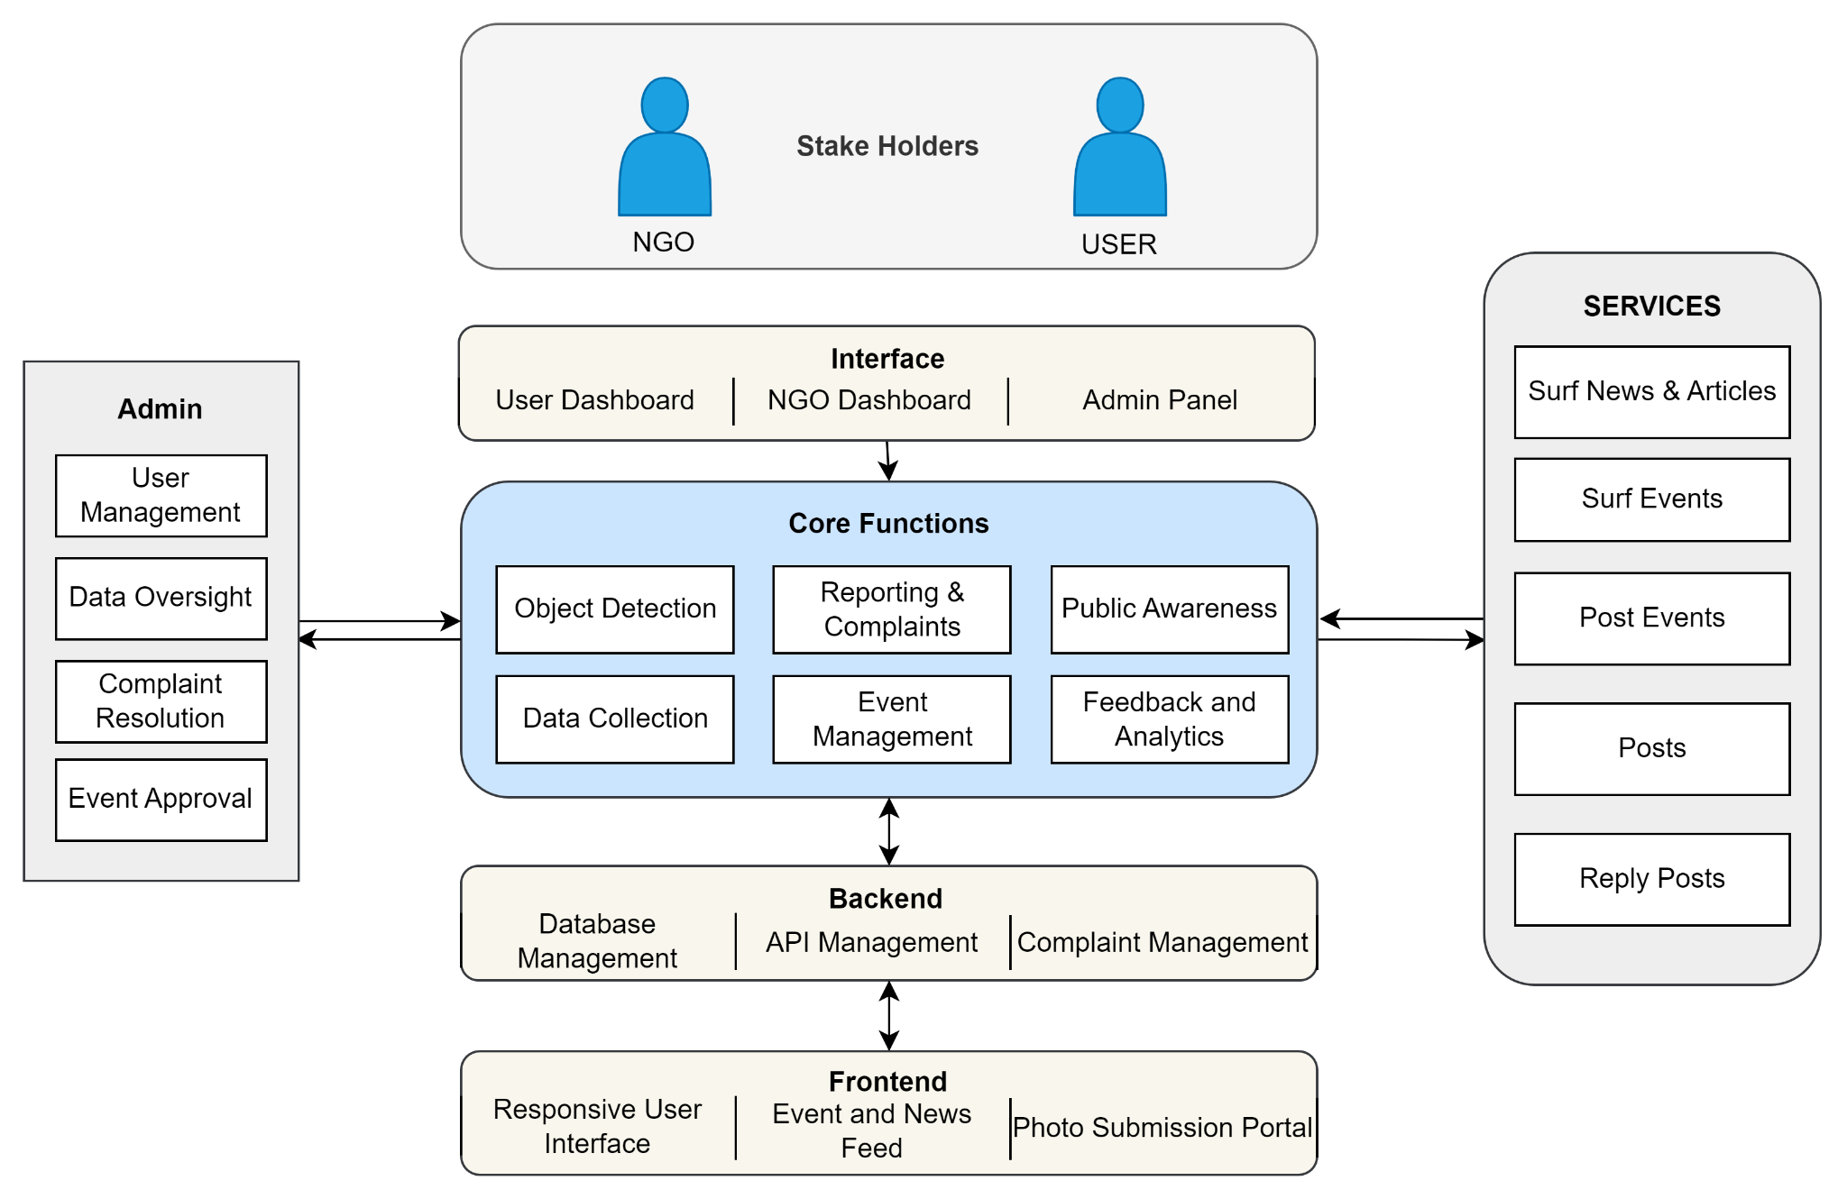

**Fig 4.1. Block diagram of the System**

Explanation for the block diagram:

This block diagram illustrates the architecture of the EnviroScan system. It is divided into multiple components and organized layers, creating a comprehensive waste management platform.

User Layer: This layer includes the primary stakeholders:

* General Public (USER): Individuals who utilize the platform to report issues, view educational content, and participate in events.
* NGOs: Organizations involved in waste management and awareness who can post events, access analytics, and collaborate with the community.

Interface: The interface provides different access points for various users:

* User Dashboard: A portal for users to submit photos, browse events, surf news, and interact with the community.
* NGO Dashboard: A management tool for NGOs to organize events, track waste reports, and view analytics.
* Admin Panel: The control center for managing the system, including user and content moderation.

Core Functions: This section encompasses the key functionalities that drive the platform:

* Object Detection: Using YOLO, detects and classifies waste types from submitted photos.
* Data Collection: Collects user-generated content for analysis and integration.
* Reporting & Complaints: Allows users to report waste-related issues.
* Event Management: Facilitates the creation and promotion of waste collection events by NGOs.
* Public Awareness: Educates the public about sustainable waste practices.
* Feedback and Analytics: Analyzes user data for insights and provides feedback mechanisms.

Services: These are the main features available to users and NGOs:

* Surf News & Articles: Access to educational resources about waste management.
* Surf Events: View and participate in upcoming events related to waste collection and awareness.
* Post Events: NGOs can create events for community participation.
* Posts: Users can engage with various posts related to waste and environment.
* Reply Posts: Enables interaction and discussion on posts.

Backend: The backend layer handles data management and processing:

* Database Management: Stores user data, photos, events, and reports.
* API Management: Facilitates communication between the frontend and core functionalities.
* Complaint Management: Backend processing for handling reports and complaints from users.

Frontend: The frontend layer provides the user interface:

* Responsive User Interface: A web and mobile-friendly interface for accessing the platform.
* Event and News Feed: Displays latest news, articles, and event details.
* Photo Submission Portal: Easy-to-use tool for uploading waste-related photos.

## 4.2. Modular diagram representation of the proposed system

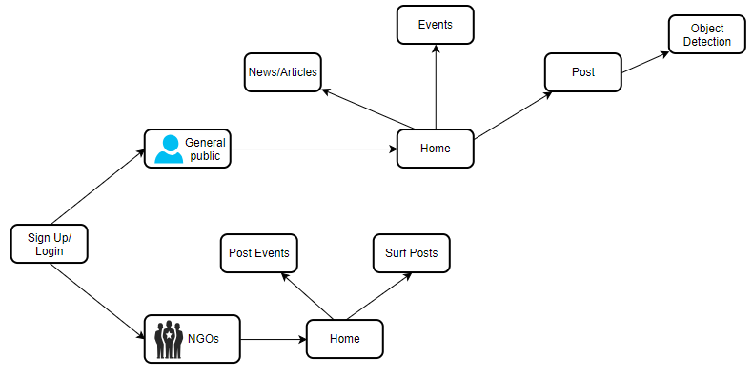

**Fig 4.2. Modular diagram of the System**

Explanation for the modular block diagram:

This modular diagram illustrates the interaction between two main user types—general public and NGOs—and their access to system functionalities. Both user types can sign up or log in to the system. Once logged in, the general public can navigate to the home page to access news/articles, events, and the post feature, which leads to object detection. NGOs can log in and access the home page to post events and surf posts. This diagram succinctly represents the user journey and the functionalities each user type can access within the system.

## 4.3 Design of the proposed system with proper explanation of each :

**Data Flow Diagram ( Level 0,1,2)**

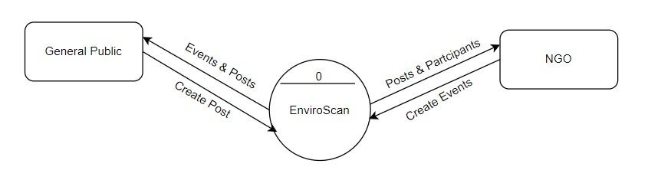

**Fig 4.3.1. DFD Level 0**

The Level 0 DFD of the EnviroScan system provides a high-level overview of the interactions between the system, general public, and NGOs. The public can create posts and receive information about events and posts through the system. NGOs can create events and view posts and participant details to plan or promote activities. The EnviroScan system acts as the central platform, facilitating the exchange of posts, events, and participant information between these two user groups.

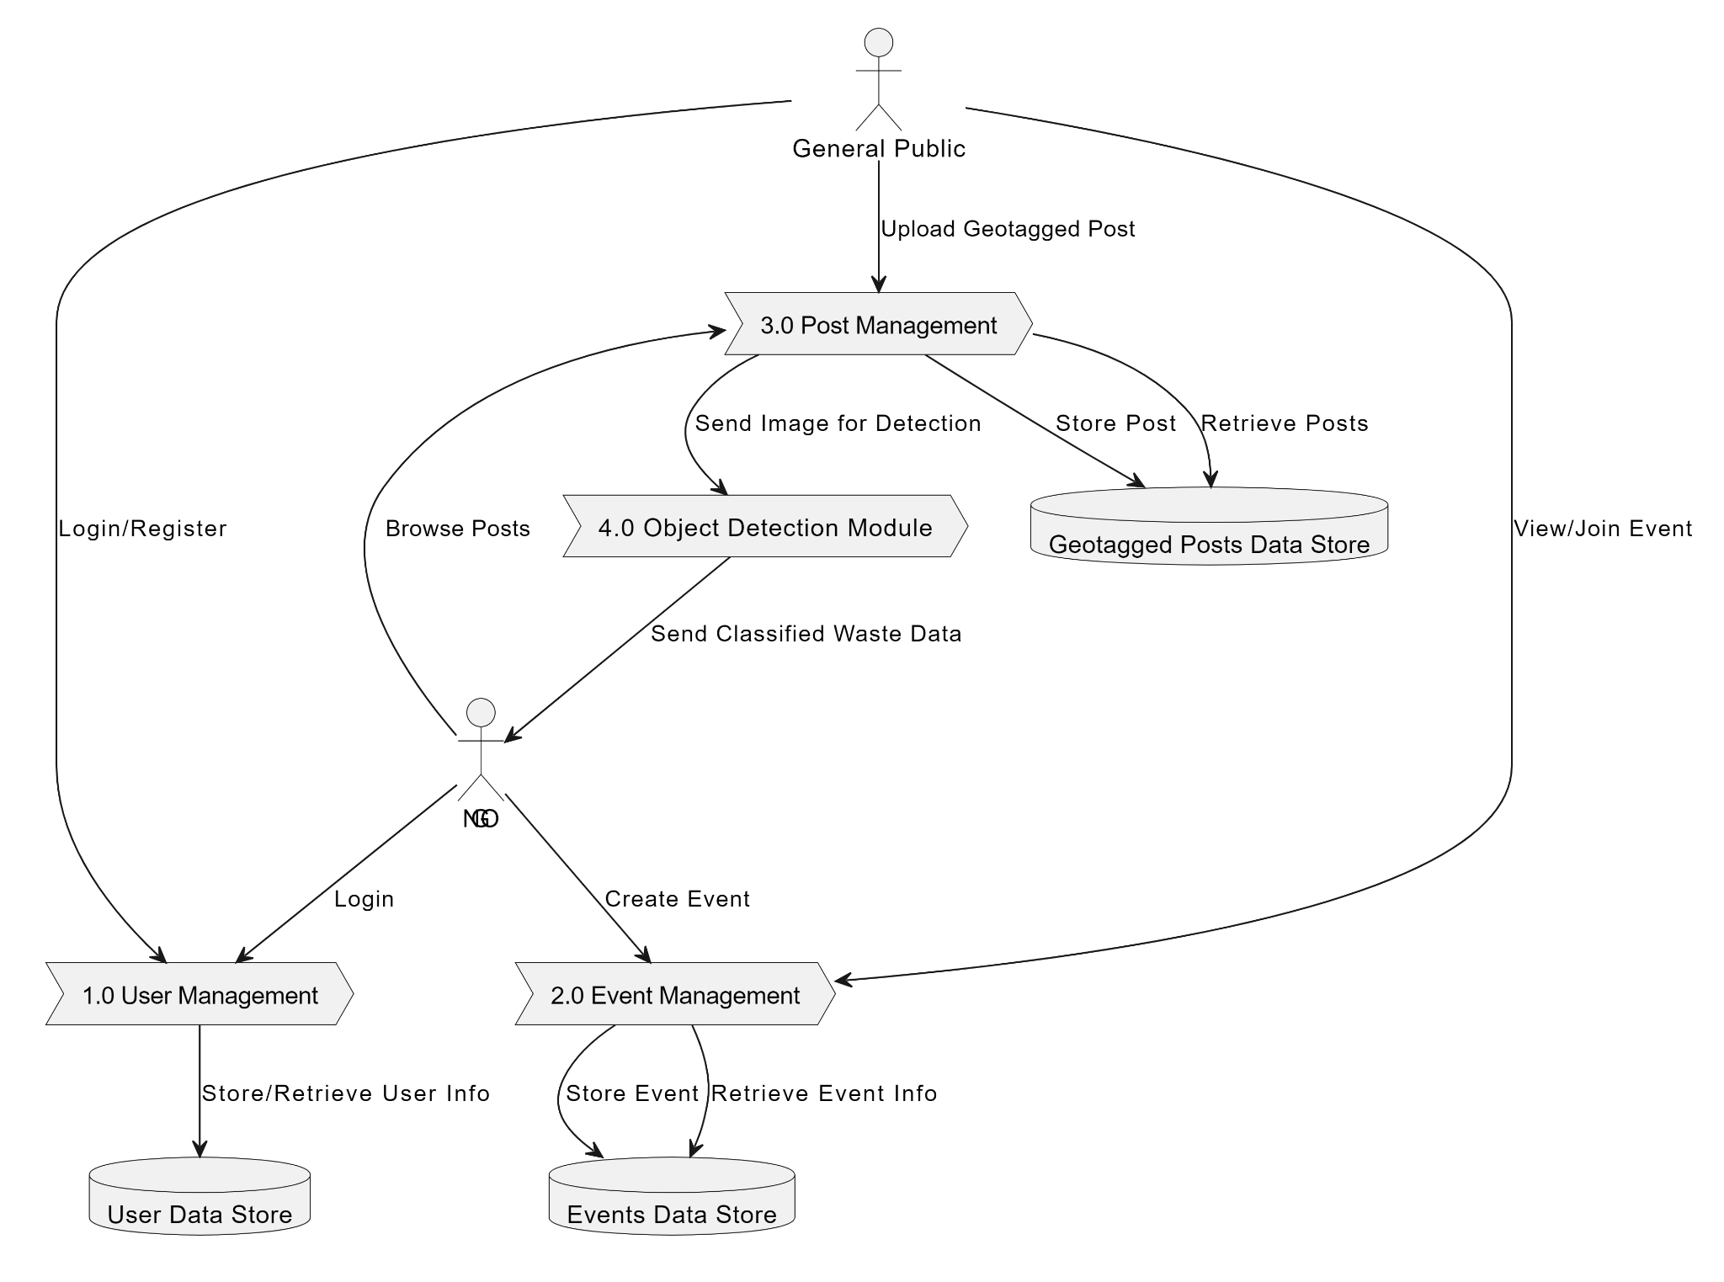

**Fig 4.3.2 DFD Level 1**

This Data Flow Diagram (DFD) Level 1 demonstrates the flow of information within the EnviroScan system. It starts with the general public and NGOs interacting with various system components. Users can upload geotagged posts, which are managed by the "Post Management" process and sent to the "Object Detection Module" for classification into categories like Glass, Bin, Metal, Plastic, and Other. The posts are then stored in the Geotagged Posts Data Store. Users can also browse posts, view, and join events. The "User Management" process handles user login and registration, storing user information in the User Data Store. Lastly, the "Event Management" process allows users to create and manage events, with event details stored in the Events Data Store

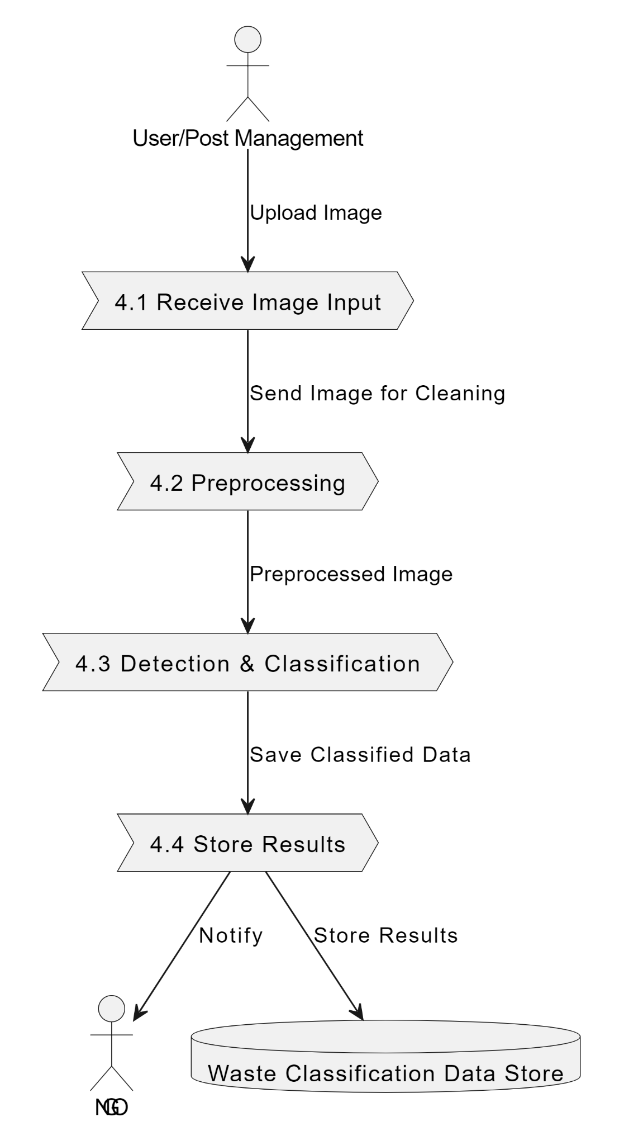

**Fig 4.3.3 DFD Level 2**

This Data Flow Diagram (DFD) Level 2 delves deeper into the intricate processes of the EnviroScan system. It begins with users (both general public and NGOs) interacting with the system by uploading images of waste, logging in, registering, and participating in events. The "Receive Image Input" process accepts these images and sends them for preprocessing, ensuring the data is clean and uniform. The "Preprocessing" stage prepares the images for the "Detection & Classification" process, which then identifies and categorizes waste into specific types: Glass, Bin, Metal, Plastic, and Other. These categorized results are subsequently saved in the Waste Classification Data Store. Furthermore, the system sends notifications to NGOs regarding cleanup needs. Additionally, user management processes handle login and registration, maintaining user details in the User Data Store. Event management processes allow the creation and management of cleanup drives, with event details stored in the Events Data Store.

## 4.4. Project Scheduling & Tracking using Timeline / Gnatt Chart

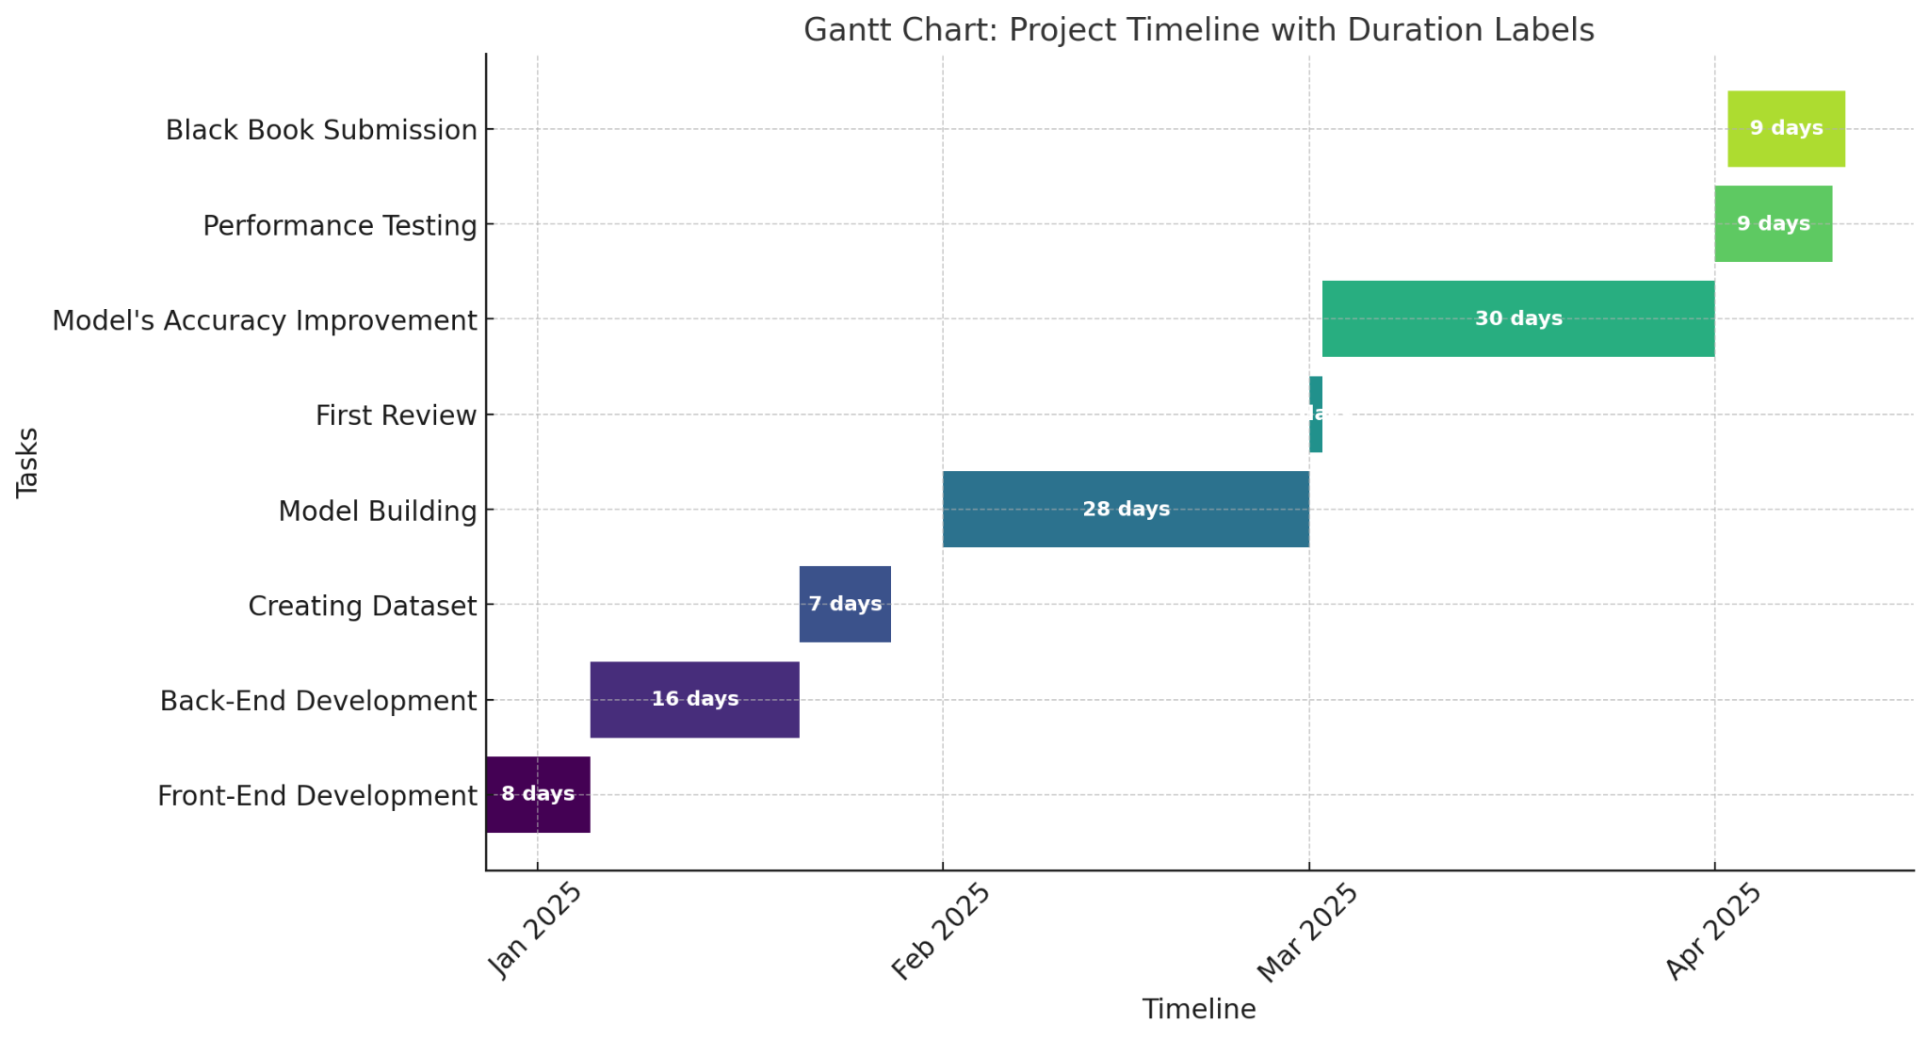

**Fig 4.4 Gantt Chart**

# Chapter 5: Implementation of the Proposed System

## 5.1.Methodology employed for development:

The methodology adopted for this project integrates advanced technology, data-driven analysis, and community involvement to create a comprehensive waste management solution. The following key steps outline the methodology used:

1. Object Detection Technology:

The project utilizes state-of-the-art object detection algorithms, such as YOLO (You Only Look Once), to analyze images submitted by users. This technology accurately detects and counts plastic waste items, providing real-time data on the type and quantity of waste. This data is then used to optimize resource allocation and waste collection schedules.

2. Data Collection and Integration:

User-generated content in the form of photos is collected via the platform. The collected data is processed and integrated into a centralized database that provides actionable insights. This allows NGOs and waste management authorities to track waste accumulation, identify high-waste areas, and allocate resources more effectively.

3. Public Awareness and Education Campaigns:

The platform includes educational resources that promote sustainable waste management practices. Campaigns are designed to inform users about the importance of recycling, waste segregation, and responsible disposal methods. By engaging users through interactive content, the platform aims to increase community participation and environmental awareness.

4. Community Reporting and Complaint Management:

A built-in complaint management system allows residents to report waste-related issues, such as missed pickups or overflowing dumpsters, in real time. This ensures quick response and resolution of complaints, fostering accountability and improving overall service delivery.

5. Collaboration with NGOs:

The platform facilitates collaboration between communities and NGOs by enabling NGOs to post about upcoming waste collection drives and events. The platform’s analytics provide NGOs with accurate data to plan and allocate resources for their activities, ensuring that they can address waste management challenges more effectively.

6. Feedback and Continuous Improvement:

Data from the platform is continually analyzed to refine and improve the waste management processes. User feedback and system performance data are used to enhance detection algorithms, optimize scheduling, and improve the overall effectiveness of the platform.

## 5.2.Algorithms and Flowcharts for the respective modules developed:

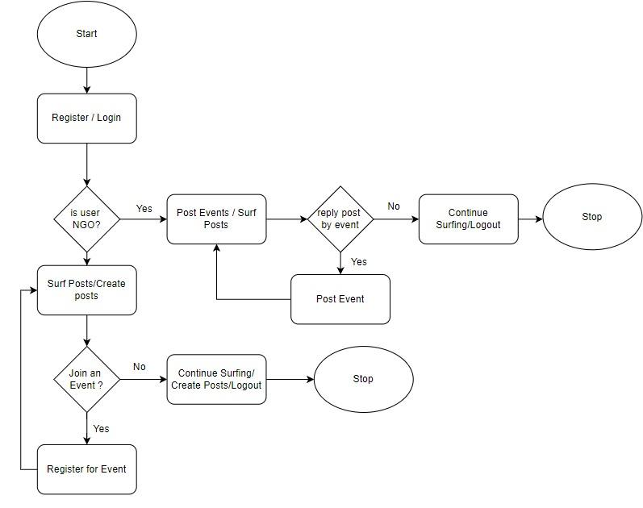

**Fig 5.2.1 Flow Chart**

The flowchart outlines the workflow of the EnviroScan system, starting with user registration or login. Based on whether the user is an NGO or not, they can either post or surf posts. NGOs can also reply to posts with events, while general users can create posts, explore existing ones, and choose to join events. If interested, users can register for events; otherwise, they can continue surfing, creating posts, or log out. The process ensures seamless interaction between NGOs and the public to promote participation and awareness in environmental activities.

## 5.3. Dataset Sources and Utilization

For the EnviroScan project, we have utilized a combination of publicly available and custom-collected datasets to train and evaluate our waste detection and classification models. One of the primary datasets used is the TrashNet dataset, which contains images of various waste categories, including plastic, metal, glass, paper, and cardboard. Additionally, we have incorporated custom-annotated images collected from user submissions to improve model generalization.

The dataset includes images labeled into the following categories:

* Plastic Waste
* Metal Waste
* Glass Waste
* Paper Waste
* Cardboard Waste
* Mixed Trash

These datasets have been used to train YOLO-based object detection models, enabling the system to accurately identify and classify waste types from user-submitted photos and videos. Data augmentation techniques have also been applied to enhance model robustness in real-world scenarios.

# Chapter 6: Testing of the Proposed System

## 6.1 Introduction to Testing

Testing is an essential phase in software development that ensures the system functions as intended and meets user requirements. The EnviroScan application, designed for waste management, undergoes rigorous testing to verify its performance, security, and reliability. The purpose of this phase is to identify and rectify potential issues before deployment, ensuring the application delivers a seamless user experience for both NGOs and normal users.

## 6.2 Types of tests Considered

**Pre testing phase**

Before releasing the application for real-world usage, internal testing is conducted to identify and fix critical issues.

* Functionality Testing: Ensures all features, such as user registration, login (for normal users & NGOs), geotagged complaint posts, and event creation, function correctly.
* Performance Testing: Evaluates how well the system handles multiple complaint posts, event registrations, and simultaneous user logins.
* Security Testing: Checks for vulnerabilities like unauthorized access, data leaks, and security risks in user authentication and data storage.
* User Interface (UI) Testing: Ensures the application layout, buttons, forms, and navigation are intuitive and user-friendly.
* Compatibility Testing: Verifies the app runs smoothly on different devices, screen sizes, and operating systems (Android & iOS).

**Beta-Testing Phase**

After internal testing, beta testing is conducted with real users (NGOs and volunteers) to assess app performance in real-world scenarios.

* Selection of Beta Testers: A group of normal users and NGOs use the app to post complaints and create/join cleanup events.
* Real-World Testing: Users report geotagged waste locations and participate in events to test app stability and accuracy.
* Feedback Collection: Beta testers provide feedback on usability, errors, and improvements.
* Bug Reporting: Users report issues like incorrect geolocation tagging, app crashes, or slow loading times.
* Data Accuracy: Ensures that complaint locations are correctly mapped, and event details are accurately stored and displayed.

## 6.3 Various test case scenarios considered

1. User Authentication:
2. Verify that normal users and NGOs can register and log in successfully.
3. Ensure incorrect credentials trigger proper error messages.
4. Complaint Posting:
5. Check if users can upload images, geotag locations, and submit waste complaints.
6. Validate that complaints appear correctly on the home screen.
7. Event Creation & Registration
8. NGOs should be able to create cleanup events with the correct date, time, and location.
9. Normal users should be able to register for events and receive confirmation.
10. Geotagging Accuracy
11. Verify that the app correctly captures and displays complaint/event locations.
12. Ensure users can manually adjust geotagged points if needed.
13. Performance Testing
14. Check app response time when multiple complaints/events are posted simultaneously.
15. Test how the app handles high user traffic.
16. Security & Data Protection
17. Ensure user data is securely stored and unauthorized access is prevented.
18. Test for vulnerabilities in complaint/event data submission.
19. Push Notifications & Alerts
20. Validate that users receive notifications for new cleanup events or complaint updates.
21. Ensure NGOs are alerted when users register for events.

# 

# Chapter 7: Results and Discussions

## 7.1 Screenshot of Use Interface(UI) for the system:

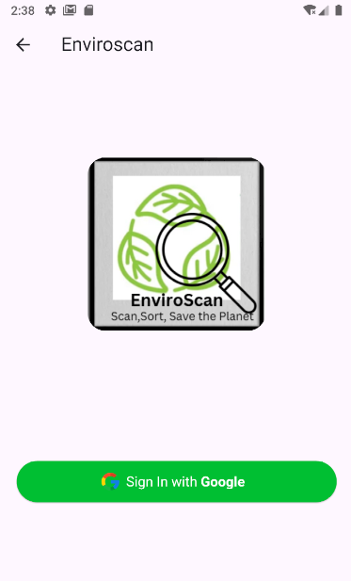 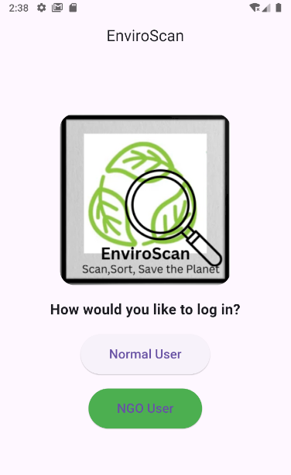

**Fig 7.1.1 Sign In Page**  **Fig 7.1.2 User Login**

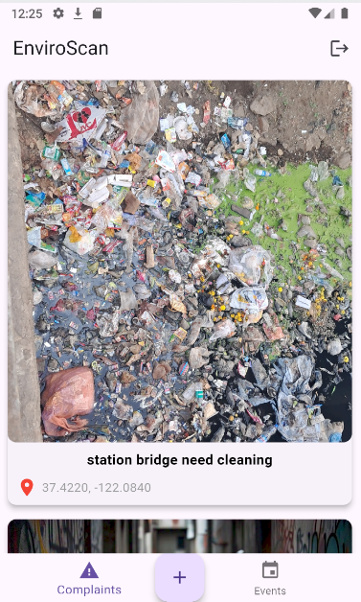 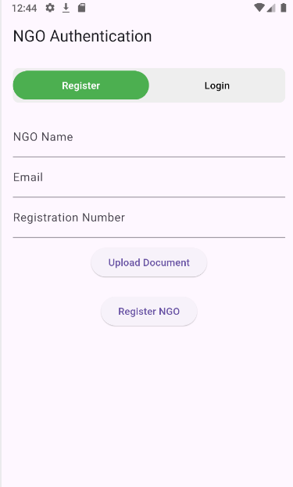

**Fig 7.1.3 Complaints page**  **Fig 7.1.4 NGO Register**

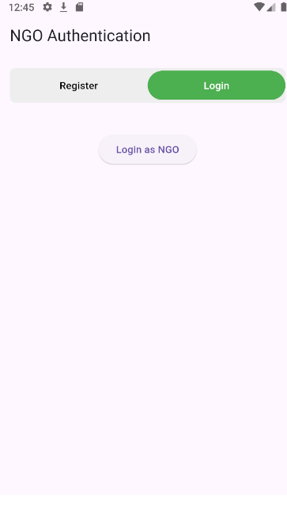 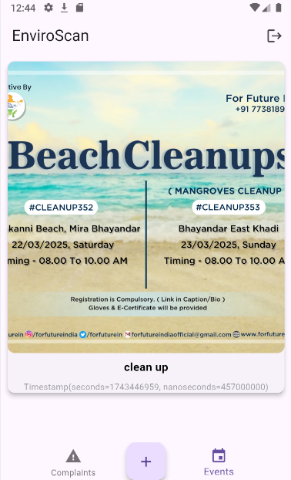

**Fig 7.1.5 NGO Login**  **Fig 7.1.6 Events Page**

EnviroScan is a waste management mobile application that bridges the gap between communities and NGOs to promote a cleaner environment. The app features a user-friendly login system with separate access for normal users and NGO representatives. Normal users can report waste-related complaints by uploading images and providing geotagged locations, ensuring authorities and NGOs are aware of areas that need attention. NGOs, on the other hand, can create and manage cleanup events, specifying details such as date, time, and location, while also allowing volunteers to register for participation. The home screen displays both complaints and events, enabling users to stay informed and take action. This interactive platform fosters community engagement, making it easier to organize cleanups and address waste disposal issues effectively.

**Model’s Predictions:**

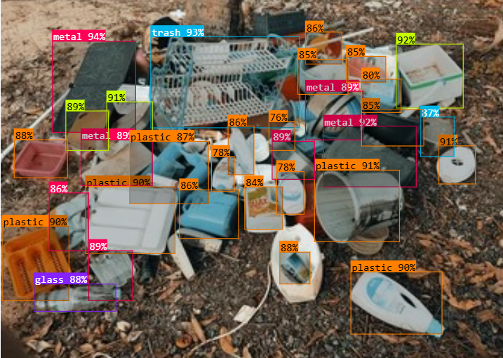

**Fig 7.1.7 YOLOv12 Model Predictions on Test Image 1**

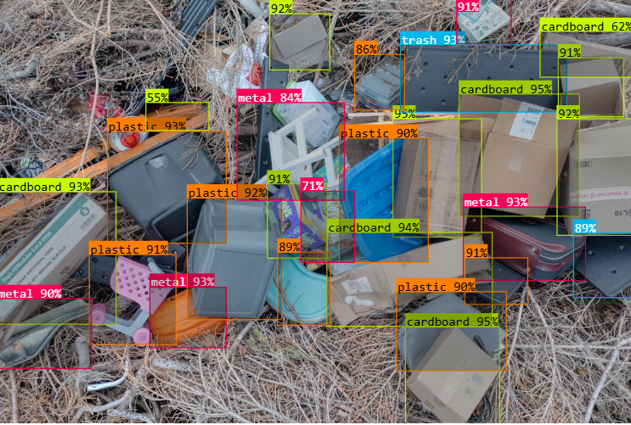

**Fig 7.1.8 YOLOv12 Model Predictions on Test Image 2**

The model successfully predicted and labeled various waste objects in real-world images, demonstrating accurate classification and precise bounding box detection.

## 7.2. Performance Evaluation Measures:

1. Accuracy: Accuracy is the ratio of correctly predicted instances to the total number of predictions made.

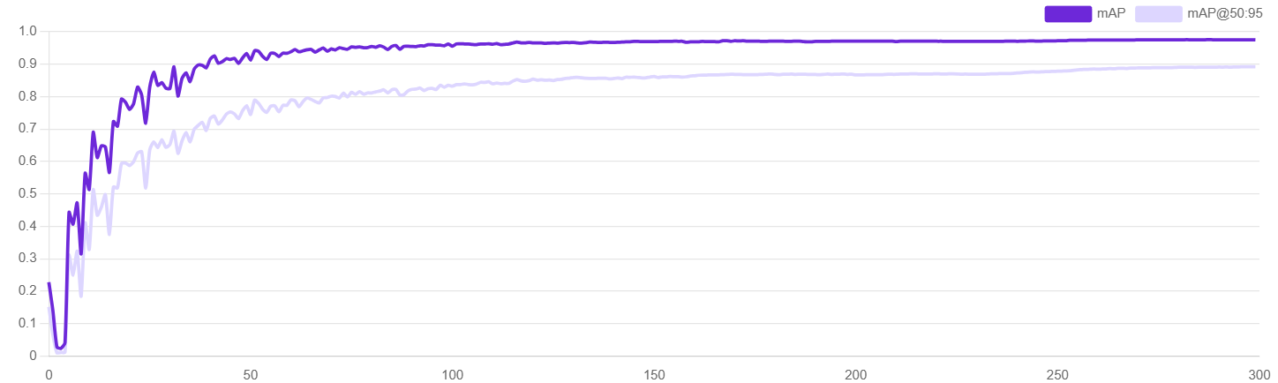

**Fig 7.2.1 Model Performance**

The top graph illustrates the model’s detection accuracy over 300 epochs using two metrics: mAP (mean Average Precision) and mAP@50:95. The mAP, shown in dark purple, rises rapidly and stabilizes above 0.95, while mAP@50:95, in light purple, follows a similar trend and flattens above 0.85. Notably, both metrics show minimal improvement after the 100th epoch, indicating that the model reaches peak performance early and maintains it consistently. This plateau suggests training beyond 100 epochs yields diminishing returns in accuracy.

1. Box Loss: Measures the error in predicted bounding box coordinates.

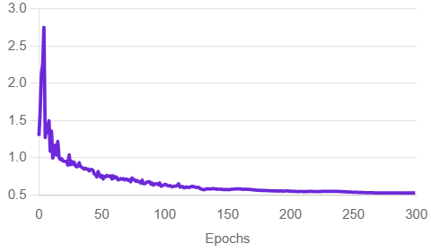

**Fig 7.2.2 Box Loss**

Box loss, which measures the accuracy of predicted bounding boxes, begins at a high value of nearly 3.0 and drops sharply in the initial training phase. By around the 100th epoch, the loss levels off and remains steady below 0.5 for the rest of the training. This consistency reflects that the model has effectively learned to localize objects early in training, with little improvement needed in later epochs.

1. Class Loss: Measures the error in classifying detected objects into correct categories.

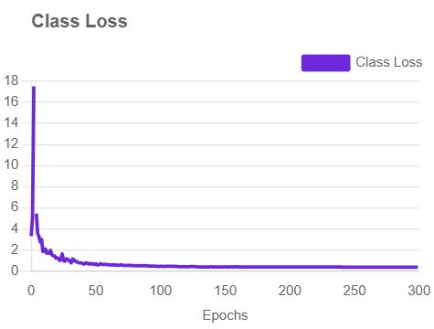

**Fig 7.2.3 Class Loss**

Class loss starts high, around 17, and drops steeply in the early epochs, indicating rapid learning in object classification. After the 100th epoch, the curve flattens and hovers near zero, showing the model has mastered the task of classifying objects with high accuracy and no further gains are observed with continued training.

1. Object Loss: Measures how well the model identifies the presence or absence of objects.

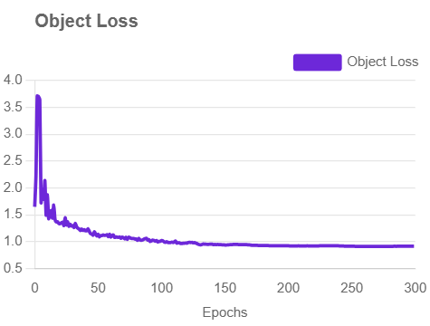

**Fig 7.2.4 Object Loss**

The object loss, which reflects the model’s ability to determine whether an object exists in a region, shows a steady decline from a peak near 4.0. This loss significantly decreases by the 100th epoch and then plateaus just under 1.0. The stability after this point confirms that the model confidently distinguishes objects from the background, and additional training does not significantly impact this skill.

1. Precision: Precision is one indicator of a machine learning model’s performance – the quality of a positive prediction made by the model. Precision refers to the number of true positives divided by the total number of positive predictions (i.e., the number of true positives plus the number of false positives). The formula is:

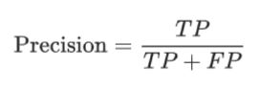

where:

TP = True Positives,

FP = false Positives.

**Model’s Precision score = 97.4%**

1. Recall: The recall is calculated as the ratio between the numbers of Positive samples correctly classified as Positive to the total number of Positive samples. The recall measures the model's ability to detect positive samples. The higher the recall, the more positive samples detected. The formula is:

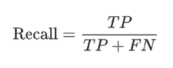

where:

TP = True Positives,

FN = false Negatives.

**Model’s Recall Score = 94.2%**

## 7.3. Input Parameters/Features considered:

The YOLO object detection model does not use traditional tabular input features like machine learning classifiers; instead, it takes images as input and learns features automatically through convolutional layers. However, the key input considerations and parameters are as follows:

* Image Input: RGB images from the dataset, resized to a standard dimension (e.g., 640×640 pixels) for consistent processing.
* Bounding Box Coordinates: Each object instance in the image is labeled with normalized coordinates representing the center (x, y), width, and height of the object.
* Class Labels: Each object is associated with a predefined class (e.g., plastic, glass, metal, paper, cardboard, trash), encoded numerically for training.
* Confidence Score (during inference): The model predicts a confidence score indicating the likelihood of an object’s presence in each bounding box.
* Anchor Boxes (in older YOLO versions): Predefined bounding box shapes used to improve object localization (optional in YOLOv5+ which uses auto anchors).

## 7.4. Comparison of Results with Existing System:

| **Other System** | **Our System** |
| --- | --- |
| Often rely on manual waste monitoring or require human intervention for classification. | Uses an automated deep learning model (YOLOv12) to detect and classify waste objects in real time. |
| Limited to basic categorization without detailed object-level detection. | Performs precise object detection with bounding boxes and class labels for multiple types of waste (e.g., plastic, glass, metal, etc.). |
| Generally lack support for fine-grained waste analytics or visual insights. | Provides detailed visual statistics, including class distribution, bounding box heatmaps, and training performance metrics. |
| May not achieve high accuracy across diverse waste types. | Achieves high accuracy and mAP using YOLOv12, with consistent performance beyond 100 epochs. |
| Often do not support integration with community-driven waste reporting platforms. | Can be integrated into apps or platforms for NGOs or communities to report and track waste more efficiently. |

**Table No. 3: Comparison of Results with Existing System**

## 7.5. Inference Drawn:

The proposed waste object detection system utilizing YOLOv12 architecture demonstrated high accuracy in identifying and classifying various types of waste, including plastic, metal, glass, paper, cardboard, and trash. From the training metrics, it was observed that the model rapidly learned during the initial epochs and stabilized in performance after the 100th epoch, with minimal variation in mAP and loss values beyond that point. The model achieved a mAP@0.5 of over 98% on the validation set, indicating strong detection capabilities. Visualizations such as class distribution, bounding box heatmaps, and loss curves confirmed that the model was well-trained, unbiased toward any class, and effective in handling object localization. These results validate the system's potential to be integrated into real-world waste monitoring solutions for automating and optimizing waste management processes in both community and industrial environments.

# Chapter 8: Conclusion

## 8.1 Limitations

Despite the innovative design and technological foundation of the EnviroScan platform, there are a few limitations that currently restrict its full potential:

1. **Limited Dataset Size**:

While efforts have been made to gather diverse and annotated waste images, the size and diversity of the dataset may not be sufficient for robust performance in all real-world conditions, especially in varied lighting or occluded scenarios.

1. **Model Accuracy in Cluttered Environments**:

Object detection models, particularly YOLO-based ones, may struggle with accurate waste classification when the waste is overlapping, partially visible, or present in cluttered environments.

1. **Internet Dependency**:

Since image uploads and event interactions require an active internet connection, users in remote or underdeveloped areas might face difficulty in accessing the platform effectively.

## 8.2 Conclusion

EnviroScan presents a comprehensive and community-focused approach to solving one of the most pressing environmental issues—inefficient plastic waste management. By integrating real-time object detection, an event-driven community platform, and a streamlined complaint management system, EnviroScan not only optimizes waste collection and resource allocation but also fosters a sense of environmental responsibility among citizens.

The system's intuitive flow—from user registration to NGO collaboration—ensures that both individual and organizational users can contribute meaningfully to waste reduction efforts. Moreover, its educational content enhances public understanding of sustainability practices, empowering a new generation of environmentally conscious citizens.

EnviroScan is not just a technological innovation but a scalable and impactful solution that blends AI with environmental stewardship to support a cleaner and greener future.

## 8.3 Future Scope

The EnviroScan platform holds vast potential for expansion and improvement. Future developments may include:

1. **Real-Time Video Detection**:

Integrating video stream processing for live detection of waste in areas like streets or garbage bins for city-level deployment.

1. **Integration with Municipal Services**:

Partnering with local governments to synchronize with city waste collection systems, enabling automated scheduling based on detection data.

1. **Multi-Language Support**:

Adding regional language support to ensure inclusivity and easier access for users in diverse linguistic communities.

## 

# 

# References

[1] United Nations Environment Programme. "Global Waste Management Outlook 2024." UNEP, 2024.

[2] G. Vinti and M. Vaccari, "Solid Waste Management in Rural Communities of Developing Countries: An Overview of Challenges and Opportunities," Clean Technologies, vol. 4, no. 4, pp. 1138–1151, Nov. 2022.

[3] K. Alfatmi, F. S. Shinde, M. Shahade, S. S. Sharma, S. S. Aruja and T. Y. Chaudhari, "E-Safe: An E-waste Management and Awareness Application using YOLO Object Detection," 2023 7th International Conference on Intelligent Computing and Control Systems (ICICCS), Madurai, India, 2023, pp. 1061-1066.

[4] J. Rashida, R. Hamzah, K. A. Fariza Abu Samah and S. Ibrahim, "Implementation of Faster Region-Based Convolutional Neural Network for Waste Type Classification," 2022 International Conference on Computer and Drone Applications (IConDA), Kuching, Malaysia, 2022, pp. 125-130.

[5] Karthikeyan, M., Subashini, T.S. & Jebakumar, R. SSD based waste separation in smart garbage using augmented clustering NMS. Autom Softw Eng 28, 17 (2021).

[6] A. Masand, S. Chauhan, M. Jangid, R. Kumar and S. Roy, "ScrapNet: An Efficient Approach to Trash Classification," in IEEE Access, vol. 9, pp. 130947-130958, 2021.

[7] W. Lin, "YOLO-Green: A Real-Time Classification and Object Detection Model Optimized for Waste Management," 2021 IEEE International Conference on Big Data (Big Data), Orlando, FL, USA, 2021, pp. 51-57.

[8] P. Saraswat and S. Lohia, "Smart Waste Management: Waste Segregation Using Machine Learning," on ResearchGate, 2023.

[9] Xiao, Y., Chen, B., Feng, C. et al. Recyclable solid waste detection based on image fusion and convolutional neural network. J Mater Cycles Waste Manag 26, 2043–2057 (2024).

[10] H. Li, C. Hu, X. Zhong, C. Zeng and H. Shen, "Solid Waste Detection in Cities Using Remote Sensing Imagery Based on a Location-Guided Key Point Network With Multiple Enhancements," in IEEE Journal of Selected Topics in Applied Earth Observations and Remote Sensing, vol. 16, pp. 191-201, 2023.

[11] H. Abdu and M. H. Mohd Noor, "A Survey on Waste Detection and Classification Using Deep Learning," in IEEE Access, vol. 10, pp. 128151-128165, 2022.

[12] Piotr Nowakowski, Teresa Pamuła, Application of deep learning object classifier to improve e-waste collection planning, Waste Management, Volume 109, 2020, Pages 1-9, ISSN 0956-053X.

[13] Chang, X. Chen, and J. Wu, "Energy-aware virtual machine placement for cloud data centers," Concurrency and Computation: Practice and Experience, vol. 29, no. 5, 2017.

[14] K. Ahmad, K. Khan and A. Al-Fuqaha, "Intelligent Fusion of Deep Features for Improved Waste Classification," in IEEE Access, vol. 8, pp. 96495-96504, 2020.

[15] Altikat, A., Gulbe, A. & Altikat, S. Intelligent solid waste classification using deep convolutional neural networks. Int. J. Environ. Sci. Technol. 19, 1285–1292 (2022).

[16] A. H. Vo, L. Hoang Son, M. T. Vo and T. Le, "A Novel Framework for Trash Classification Using Deep Transfer Learning," in IEEE Access, vol. 7, pp. 178631-178639, 2019.

[17] Xia W, Jiang Y, Chen X, Zhao R. Application of machine learning algorithms in municipal solid waste management: A mini review. Waste Management & Research. 2022;40(6):609-624.

[18] Ping, Ping & Xu, Guoyan & Kumala, Effendy & Gao, Jerry. (2020). Smart Street Litter Detection and Classification Based on Faster R-CNN and Edge Computing. International Journal of Software Engineering and Knowledge Engineering. 30. 537-553. 10.1142/S0218194020400045.

[19] P. Zhang, Q. Zhao, J. Gao, W. Li and J. Lu, "Urban Street Cleanliness Assessment Using Mobile Edge Computing and Deep Learning," in IEEE Access, vol. 7, pp. 63550-63563, 2019.

[20] G. Salvia, N. Zimmermann, C. Willan, J. Hale, H. Gitau, K. Muindi, E. Gichana, and M. Davies, "The wicked problem of waste management: An attention-based analysis of stakeholder behaviours," Journal of Cleaner Production, vol. 326, p. 129200, 2021.

# Appendix - I

## 1.Paper:-

**Paper published:**

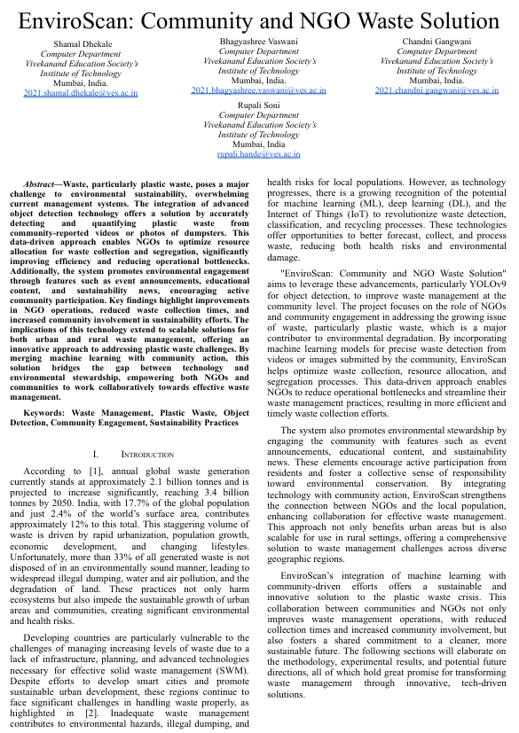

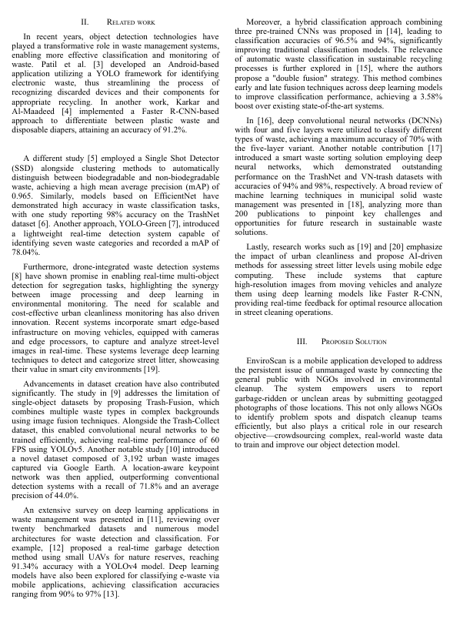

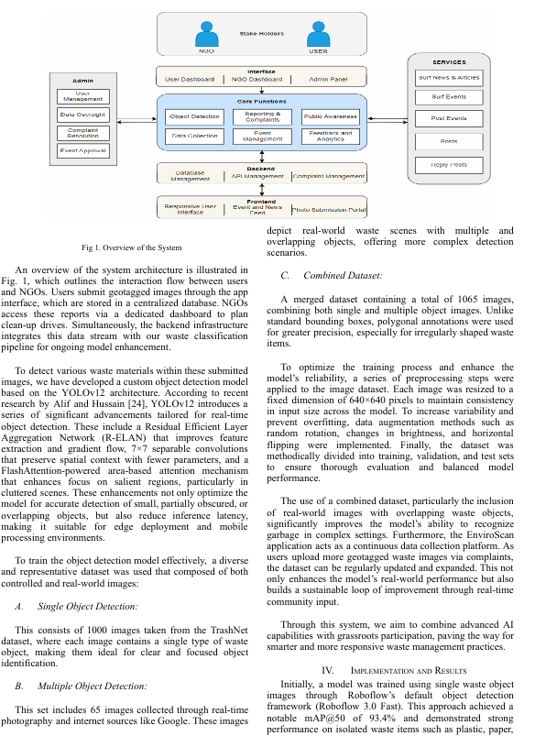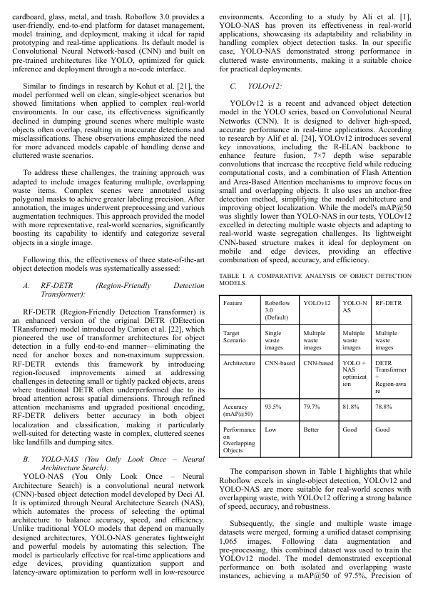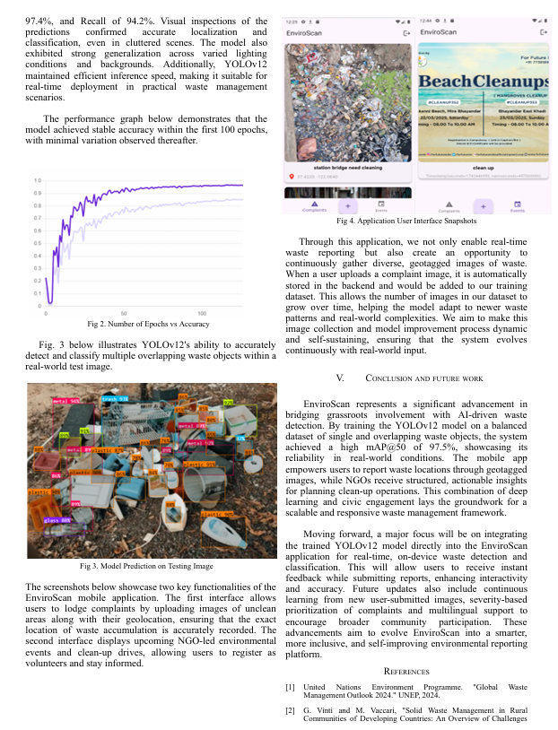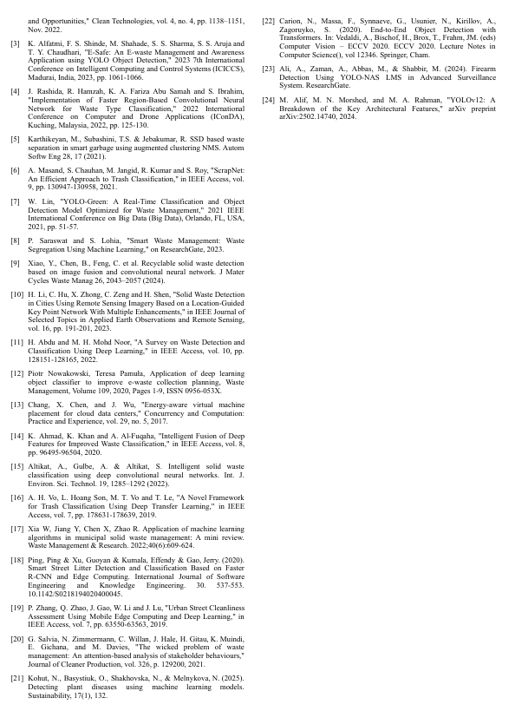

**Plagiarism report**

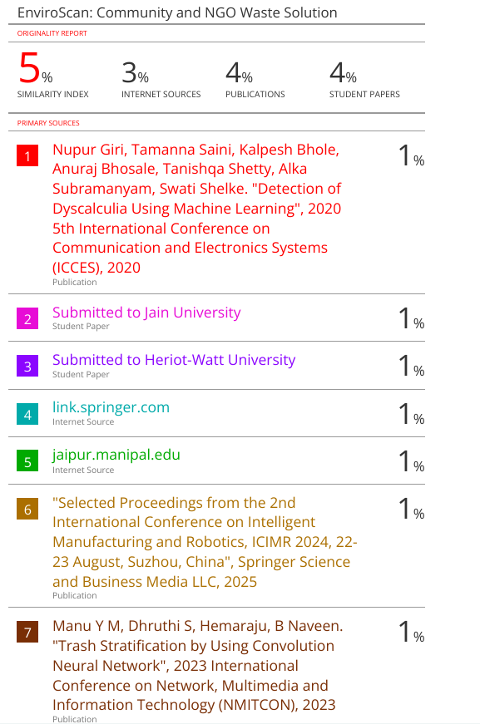

## 2. Progress review sheet 1 and 2

